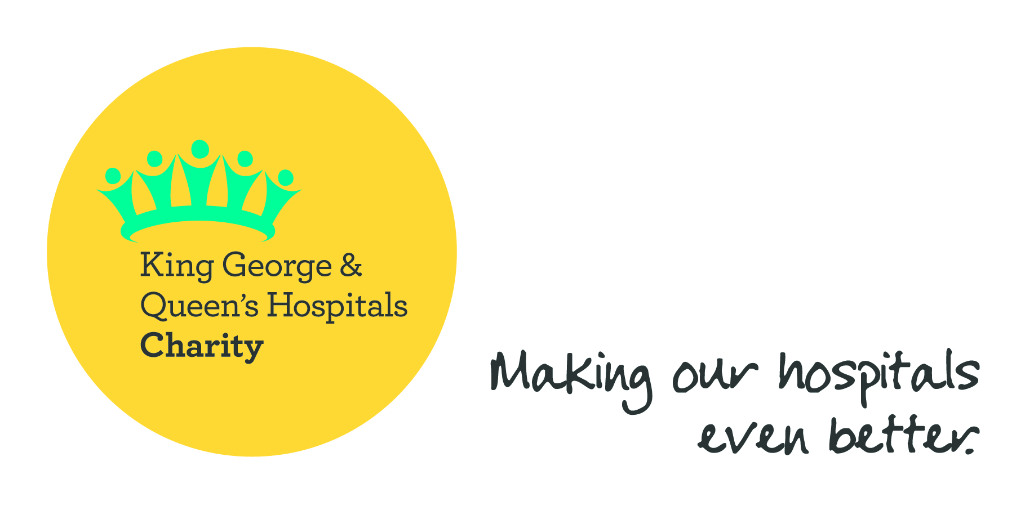

**Name of fundraiser:………………………………………………………..**

**Insert here a message about what the supporter is doing and why and ask that people sponsor them.**



Giving under Gift Aid means that so much more money can be raised at no extra cost to our donors. Please tick for Gift Aid if you can – conditions overleaf.

|  |  |  |  |  |  |  |
| --- | --- | --- | --- | --- | --- | --- |
| **Sponsor’s Full Name** | **Sponsor’s Home Address** | **Postcode** | **Donation**  **Amount** | **Date**  **paid** | **Gift**  **Aid?** | **Keep in**  **touch?\*** |
| *E.g. Tracey Phelps* | *7 Ash Rd, Romford* | *RM1 1AA* | *£10.00* | *2.12.17* | *✓* | *✓* |
|  |  |  |  |  |  |  |
|  |  |  |  |  |  |  |
|  |  |  |  |  |  |  |
|  |  |  |  |  |  |  |
|  |  |  |  |  |  |  |
|  |  |  |  |  |  |  |
|  |  |  |  |  |  |  |
|  |  |  |  |  |  |  |
|  |  |  |  |  |  |  |
|  |  |  |  |  |  |  |
|  |  |  |  |  |  |  |
|  |  |  |  |  |  |  |

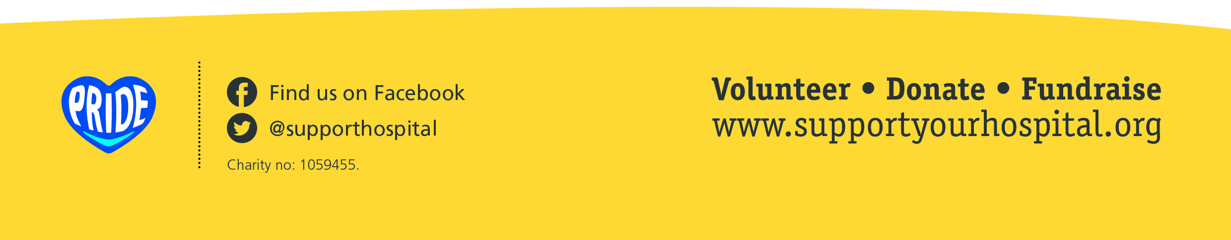*We take pride and care to spend your donation wisely. If you’d like to know how your donation has helped to make our hospitals even better please tick this box. We never sell, share or swap personal details with any other organisation or third parties and you can opt out of communications at any time by emailing hospitalcharity@bhrhospitals.nhs.uk.

**Continuation**

Please photocopy if further sheets are required or call the Charity Office on 01708 504322!

|  |  |  |  |  |  |  |
| --- | --- | --- | --- | --- | --- | --- |
| **Sponsor’s Full Name** | **Sponsor’s Home Address** | **Postcode** | **Donation**  **Amount** | **Date**  **paid** | **Gift**  **Aid?** | **Keep in**  **touch?\*** |
|  |  |  |  |  |  |  |
|  |  |  |  |  |  |  |
|  |  |  |  |  |  |  |
|  |  |  |  |  |  |  |
|  |  |  |  |  |  |  |
|  |  |  |  |  |  |  |
|  |  |  |  |  |  |  |
|  |  |  |  |  |  |  |
|  |  |  |  |  |  |  |
|  |  |  |  |  |  |  |
|  |  |  |  |  |  |  |
|  |  |  |  |  |  |  |
|  |  |  |  |  |  |  |
|  |  |  |  |  |  |  |
|  |  |  |  |  |  |  |

If I have ticked the box headed ‘Gift Aid? √’, I confirm that I am a UK Income or Capital Gains taxpayer. I have read this statement and want the charity named above to reclaim tax on the donation detailed below, given on the date shown. I understand that if I pay less Income Tax / or Capital Gains tax in the current tax year than the amount of Gift Aid claimed on all of my donations it is my responsibility to pay any difference. I understand the charity will reclaim 25p of tax on every £1 that I have given. Remember: You must provide your full name, home address, postcode & ‘√’ Gift Aid for the charity to claim tax back on your donation. King George & Queen’s Hospitals Charity is a registered charity, no. 1059455.

----------------------------------------------------------------------------------------------------------------------------------------------

|  |  |
| --- | --- |
| Total donations received | £ |
| Total Gift Aid donations | £  **What a star!!!** |
| Date donations given to KGQHC |  |

Please return your completed sponsor forms and sponsorship money to:

King George & Queen’s Hospitals Charity, Queen’s Hospital, Rom Valley Way, Romford RM7 0AG

Please make any cheques payable to ‘King George & Queen’s Hospitals Charity’.

For other ways to pay in your money call us on 01708 504322.

|  |  |
| --- | --- |
| **For KGQHC use only** |  |
| Non-Gift Aided Money Received | £ |
| Gift Aided Money Received | £ |
| Total Raised | £ |
| Date Entered on Harlequin |  |