**King George & Queen’s Hospitals Charity**

**Annual Report and Accounts**

**2022 - 2023**

**List of Contents Page**

Reflections from the Chair 3

A Word from the Head of Fundraising 4

Our Charity vision 5

The Charity Team 6

Sources of income and how we raised our funds 7

Sources and breakdown of expenditure 8

How we used our funds 9

Case studies 11

Fundraising events 13

Thanks to our supporters 15

Gifts in kind 18

Future plans… 20

Index for the Annual Accounts

* Administrative details 22
* Corporate Trustee’s report 24
* Statement of Trustee responsibilities 40
* Independent auditor’s report to the Trustees of BHRUT
* Charity Fund 41
* Statement of Financial Activities for the year ending 31.03.23 46
* Balance Sheet as at 31.03.23 48
* Statement of cash flows for the year ending 31.03.23 49
* Notes to the Accounts 50
* Glossary of terms 71

With special thanks to 72

**Reflections from the Chair**

Preparing this annual report and looking back over the last twelve months, I have been reminded just how much our charity has achieved even working through a year of record inflation. We had to brace ourselves for the inevitable changes of a post covid world, adopting innovative ideas in fundraising to enable us to carry on supporting our hospital community.

As prices have risen rapidly all parts of our community have been affected, and we knew a challenged economy was going to be a concern. In the main, our hospital supporters are local people, young families, and an ever-growing aging community, the very people hardest hit by inflation. We have already seen the effect of this economy locally, with the closure of many of our most prominent high street names, and an ever-increasing reliance on food banks for so many. Our community has been hard hit and rising prices and fears over job security have undoubtedly had a knock-on effect on charitable income.

Despite all of this we are encouraged to see that our income line has managed to grow a little, due to grants received for specific projects from NHS Charities Together. I applaud the commitment of our charity team during such challenging times, and the support received from our volunteers and Charity Ambassadors in bringing these projects to life. I would like to thank everyone that has supported us in so many ways over the last twelve months, we have had to be imaginative and resourceful, but with their support we have been able to provide our medical staff, patients, and visitors with many extras that have eased the journey through our hospitals for all.

**A word from the Head of Fundraising**

After launching our Techno Vols programme in 2021, we have continued to support the reminiscence project, combating loneliness and isolation for our elderly with funding from NHS Charities Together. We have also shared our funding with our own volunteer services department to provide more support around our hospitals. We have agreed to fund a two-year contract for a Care Navigator for AGE UK, to support elderly patients as they return home from hospital. We have funded sixteen new touch screen RITA units for the elderly, providing even more interactive entertainment, and stimulating cognitive activities for those that feel lonely or isolated while in hospital care. We have recruited volunteers to help us deliver the service and delivered training to our medical teams in using the RITA screens, which also help to overcome language barriers.

We were delighted to cut the ribbon on our newly installed playroom on Tropical Lagoon children’s ward, unveiling a selection of wall mounted sensory panels, comforting murals, and interactive aquarium (see more on page 10). We carried on the play therapy theme with murals for our children’s ED units, and a Christmas party for 70 children under the care of paediatric homecare and outpatients.

As we approached Christmas, we were delighted to find that even after a two-year break, our regular supporters came back on mass to support our Superhero Charity Ball. The Superhero theme was chosen to recognise our own NHS heroes, who cared for our community during the pandemic. We were thrilled that the event sold out (see more on pages 13 and 14). Furthermore, our Chair was delighted to be able to announce on the night, that we had managed to pay off the final payment on the three year Da Vinci Robotic Arm project, which was met with a huge round of applause.

It has been a year of unexpected challenges, but also one I feel we can all be proud of.

**Our Charity vision**

King George & Queen’s Hospitals Charity is a local NHS Charity supporting two local hospitals: King George Hospital in Ilford and Queen’s Hospital in Romford. Our focus is clear – we work alongside and in support of Barking, Havering & Redbridge University Hospitals NHS Trust and the Trust’s staff and clinical teams to make our hospitals even better for our patients and their families.

Our Charity does not subsidise the core responsibilities of the NHS, but we enhance the essential services provided by them to make the hospital journey the best it can be for everyone.

Our charitable donations fall into four categories:

* Medical equipment
* Information & technology
* Comfort & the environment
* Research & training

We actively create events, challenges, and campaigns to encourage our community to help us raise funds, and we are the custodians of all voluntary donations and charity investments. We take pride in ensuring our supporters’ donations will be wisely spent and restricted to a specific area if requested.

Our role is to listen to the concerns, ideas and innovations of both our patients and staff and to help turn their great ideas into reality - making the hospital experience better for all.

Charity begins at home and our charity vision is to support our hospitals and make them better equipped and more comfortable for all who need our care both now and in the future.

**The Charity Team**

**Sources of income and how we raised our funds**

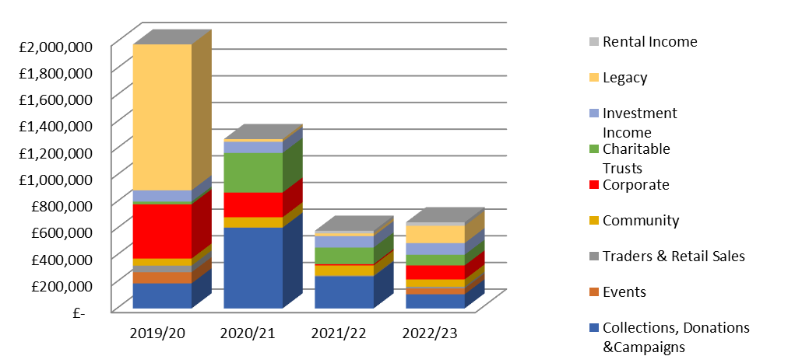**Charity income for the past 4 years**

Income dipped in 2021/22 with the first round of inflation, but this year 22/23 income is beginning to rise again supported by some generous legacy donations, and grants from NHS Charities Together. However, community donations and collections are still slow, and will need attention in the coming year. Rental income has held firm and will increase further in the coming year as we release one of our renovated houses to the rental market. Our event line has only just restarted but shows promise.

**Investment properties**

Our property portfolio increased as house prices rose during 2022/23. We are also now valuing our properties with sitting tenants which affects the total value of the houses should we wish to sell.

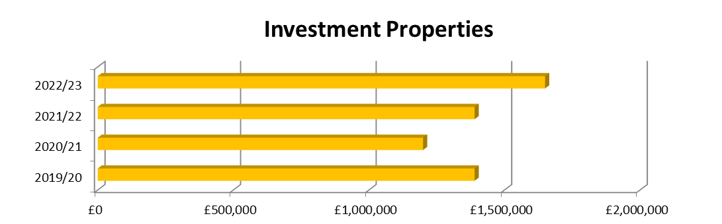

We spent in total £828k bringing benefit to patients and staff, while maintaining all our core investments, meaning the charity still has a total worth, including investments, of £3,545k.

**Sources and breakdown of expenditure**

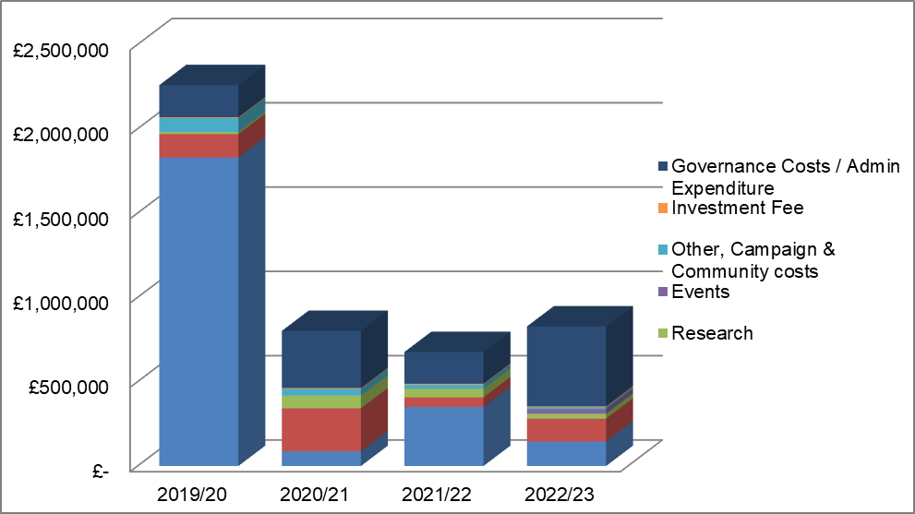**Charity expenditure for the last 4 years**

**Breakdown of expenditure as a % of total spent**

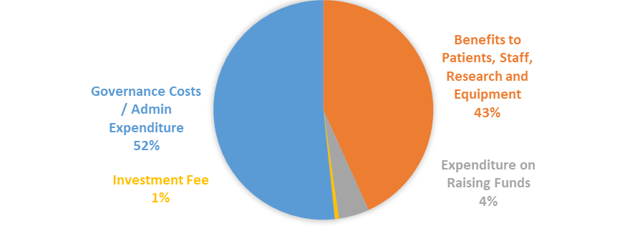

**How we used our funds**

**Medical Equipment -** Bronchus Set for Children’s Asthma

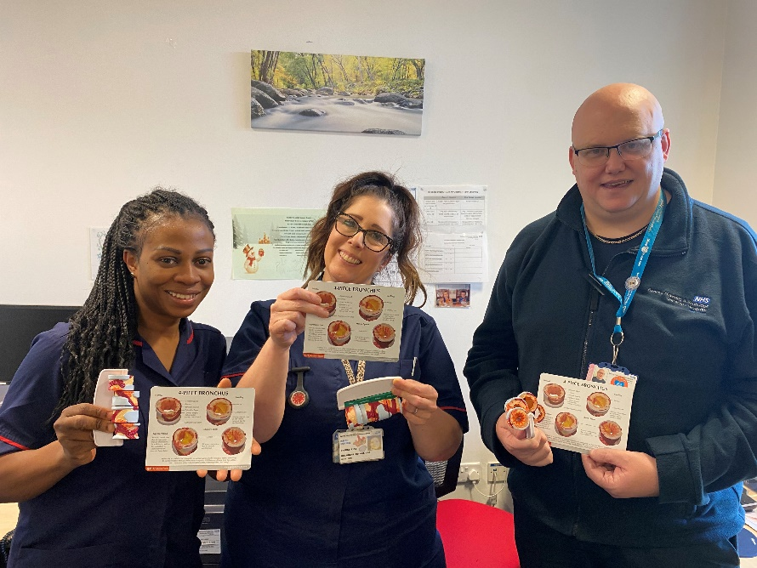

**Staff with the Bronchus Set**

We helped fund anatomical model bronchus sets for our children’s asthma wards. Helen Espline, Children’s Clinical Nurse Specialist said: “The models are extremely beneficial, they are ideal for demonstrating the effects of asthma as a respiratory condition”.

**Research and training –** Surgery Leadership Away Day

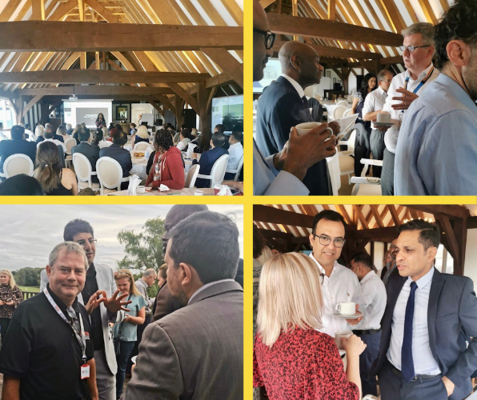

**Photos from the away day**

Our charity was proud to help organise BHRUT’s Surgery Leadership Away Day, hosted on the beautiful grounds at South Essex Golf Club. It was a pleasure to be joined by a variety of guest speakers, including Prof Partha Kar OBE, Matthew Trainer, Mamta Vaidya, Thangadorai Amalesh, Kathryn Halford, among others, who delivered inspiring messages.

Attendees of the event provided us with positive feedback, noting that it was a truly motivational and informative experience.

**Technology and information –** RITA devices

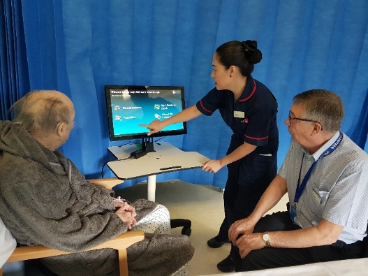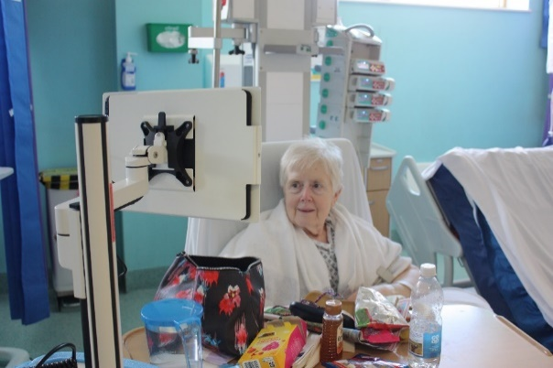

**Patients enjoying RITA**

We have provided additional RITA screens in our critical and elderly care wards. RITA is a preloaded touch screen system with stimulating entertainment, such as films, music, games, armchair exercise and much more which have been helping to keep our patients active and entertained.

**Comfort and the environment –** Tropical Lagoon refurbishment

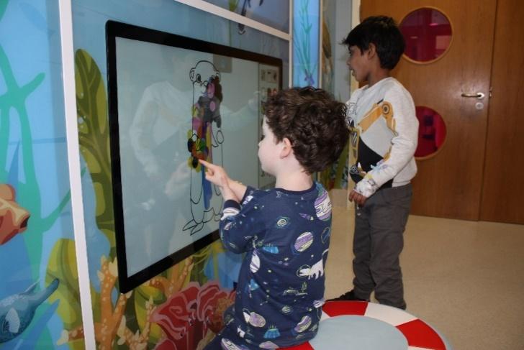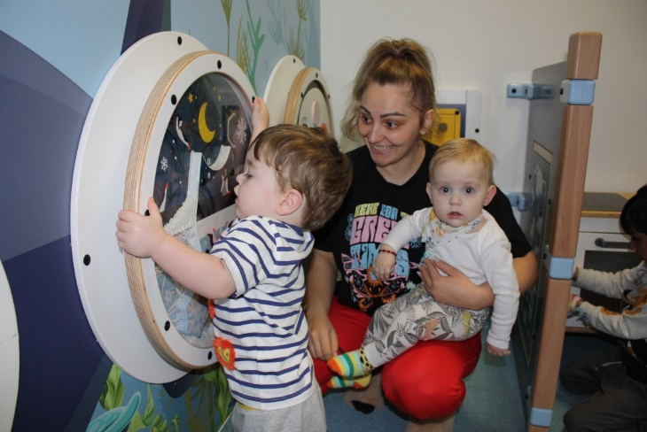

**Children enjoying the new equipment**

The children’s play area refurbishment has been completed. Due to the pandemic, the play area had to be used as an emergency doctors meeting room, and it needed some TLC (Tender loving care). Our charity believes play is essential for all children, even while in hospital. So, we aimed to create a fun and engaging space for children to enjoy while in our hospitals.

The playroom has been transformed into an extraordinary under the sea themed area, complete with an interactive play system and various wall games. The interactive screen software provides an immersive play experience, featuring numerous educational games that keep children stimulated and engaged. The play system also creates a calming atmosphere by producing soft, ocean-like sounds. Our children have had a blast playing in the room, and it’s often a challenge getting them to leave!

**Case studies**

**Matt and Rosie McGorry**



**Matt McGorry and fellow runner**

In December 2022, Matt took part in ‘The Southend Rudolph Run’, a popular festive 5 mile run fundraiser along the Promenade. Matt decided to run for King George and Queen’s Hospitals Charity after the amazing care his wife Rosie received at Queen’s Hospital.

In October 2022, Rosie was involved in a football accident, and was cared for by our Sahara B Ward and Neurosciences Therapy Team.

Matt said: “Rosie’s fortitude is what’s driving her on, but nothing could have been achieved without the expertise, care and selflessness of the team. Rosie had a major surgery and was given a 2% chance of being able to walk again. Since then, she has overcome every challenge faced and is recovering extremely well”.

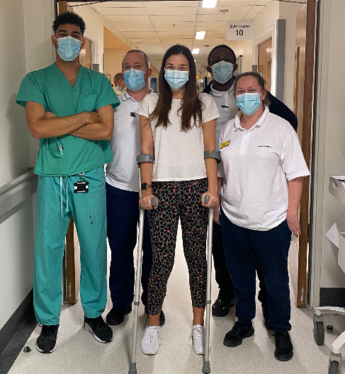

**Rosie McGorry**

Matt adds: “Donate whatever you can to this amazing hospital and help them give the same opportunities to other patients who are going through and will go through what Rosie is tackling”. Due to Matt’s dedication and the support he received, over £3,000 was raised!

**Kishan Majithia**

In October 2021, Reetha Thakkar was diagnosed with an aggressive form of breast cancer. Since then, she has been bravely battling her illness and has undergone an intensive and gruelling programme of chemotherapy and radiotherapy in the Sunflower Suite at Queen's Hospital. It was an incredibly difficult, worrying and challenging time for Reetha's family. Reetha has shown courage and strength to fight her illness, and this is in large part down to the amazing care and support she has received from the staff in the Sunflower Suite.

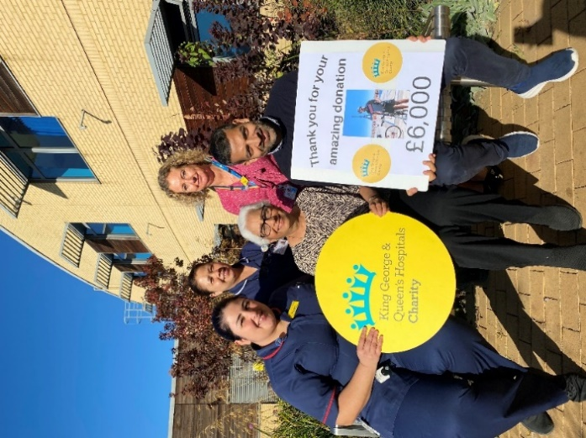

**Reetha and Kishan with staff from the Sunflower Suite**

Kishan, Reetha's son in-law, decided to fundraise for the department due to their genuine care and support, which the family will be eternally grateful for. Kishan cycled from London to Paris in August 2022, covering the distance of 281 miles over four days and cycling for approximately 8-10 hours each day. Due to Kishan’s hard work and the support he received, over £6,000 was raised for the Sunflower Suite to improve patient experiences!

Kishan said: "As a family we felt helpless when mum was ill, so I wanted to think of a way to try and give something back to help the team for all their help. I hope the funds can continue to support more people in their fight against cancer".

**Fundraising events**

**The Big Charity Quiz**

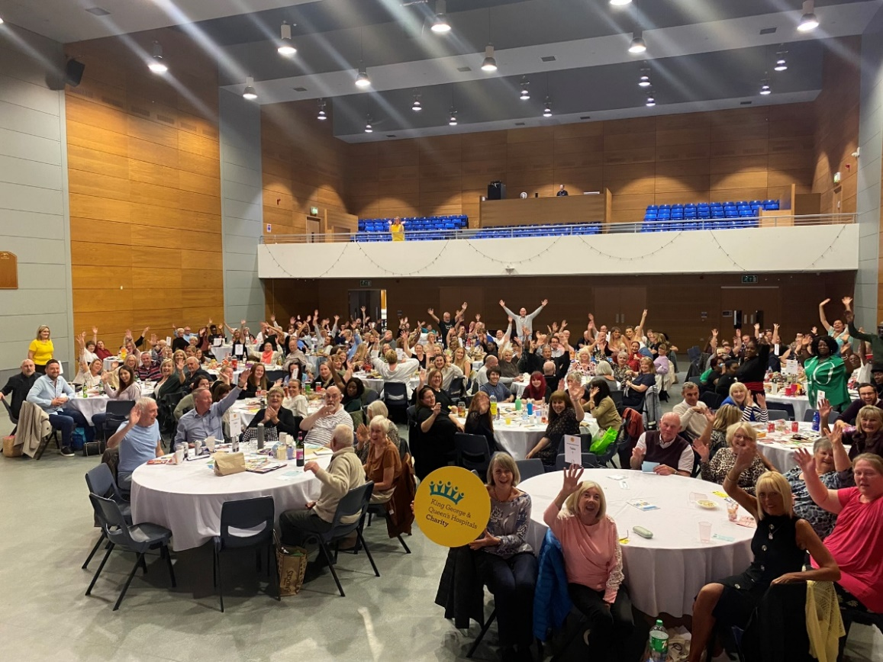

**Enjoying the quiz**

We hosted our third annual Big Charity Quiz in September 2022, and what a night we had! The room was filled with enthusiastic quizzers raring to go. Funds raised helped us continue providing the extras in our local hospitals.

Both staff and members from our local community attended, and it was great to see some new faces as well as our regular supporters.

We received plenty of positive testimonials from those who joined us.

**The Super-Hero Charity Ball**

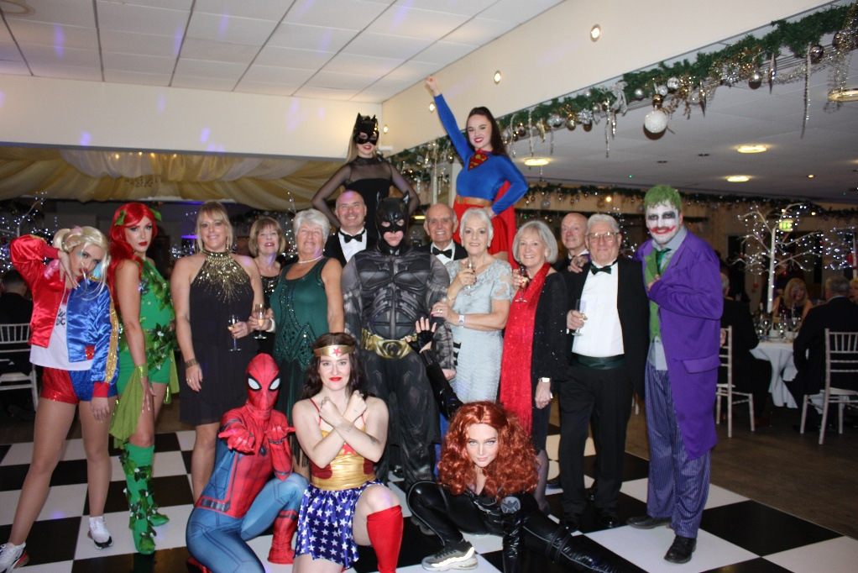

**Guests and performers at the ball**

We held our first Charity Ball since the pandemic and it was an incredible success, raising funds for our children’s services! The event took place at Orsett Hall Hotel with a variety of fantastic entertainment.

Guests were greeted by spectacular fire breathers and stilt walkers, adding flare and thrill to the bubbly and canape reception. A fabulous three course meal was served, whilst the guests were entertained with stunning vocals from a professional jazz singer.

The event included a raffle, main auction and over 25 silent auction prizes, including golf days, restaurant vouchers and a £500 Amazon gift card! Spectacular entertainment continued throughout the evening, including a master illusion show leaving guests on the edge of their seats.

Our guests were extremely generous, and the room was filled with our amazing supporters.

**Children’s Christmas Party**

We held our first Christmas party for children who have been cared for in our hospitals, across departments including asthma, diabetes, haemoglobinopathy and our homecare team.

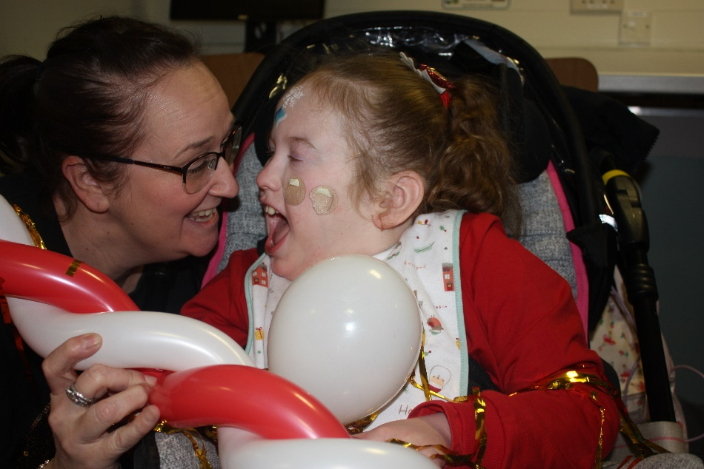

**Isla and her mum had the best time!**

Children had a chance to spend time together away from the hospital wards and focus solely on having fun!

Activities included arts and crafts and face painting, while there was entertainment from Jade Foster-Jerrett and Skittleman the Entertainer. Lunch was provided with every child receiving a jolly snowman box of goodies, before each received a present from Santa himself, who then told a magical story.

Suki Haywood was there with daughter Isla who has cystic fibrosis and Angelman syndrome. She said: “It was a lovely surprise to be invited. Isla had lots of fun and it was great for her to be with other children. The party was very well organised with lots to do”.

**Thanks to our supporters**

Our Trust Chaplain, Grace Allick took part in the sponsored Santa in the City Run in December 2022. She raised over £900 to help fund Sleepwell packs for patients who stayed overnight with us in hospital on Christmas Eve.



**Trust Chaplain Grace Allick**

Sleepwell packs are designed to support patients who feel disturbed during the night and are unable to sleep. The packs contain an eye mask and ear plugs, which are especially useful for patients in our emergency departments.

We know that sleep is important to overall health and well-being but it's especially important to the healing process.

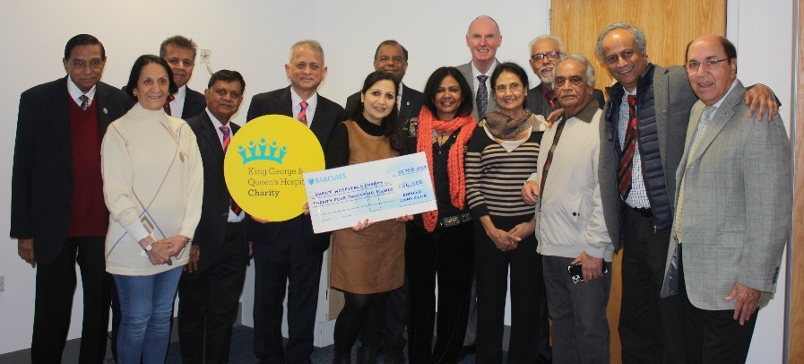

**Members of Enfield Lions Club**

One of our long serving doctors, Dr. Prakash Naik, and members of Enfield Lions Club raised an incredible £24,000 for our Intensive Therapy Unit (ITU).

The club, which has been running since 1974, includes a group of local men and women who come together to help others. All funds collected by the Lions from the public goes directly to charities. Prakash was the president of Enfield Lions Club for the year 21/22. Prakash, who has been working in our ITU for over 19 years chose to raise funds to help the hospital so close to his heart. The money was raised by the club hosting a dinner and dance, as well as generous donations from the local community.

Funds raised will go towards improving our ITU environment, such as providing access to entertainment and comfortable furniture for patients and families.

**Corporate Support**

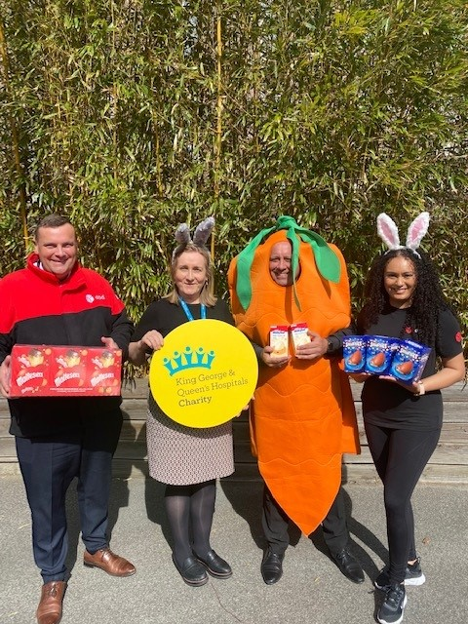

**DPD donated hundreds of Easter Eggs to our children's wards**

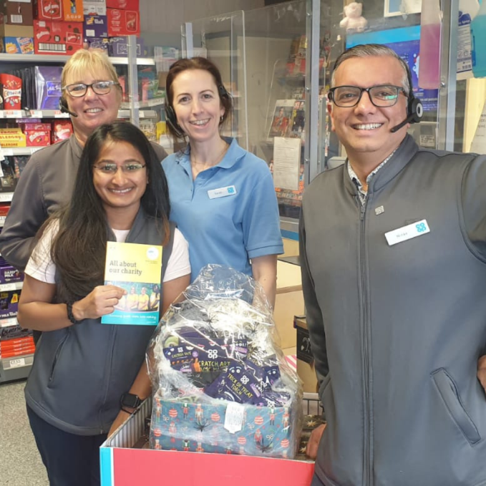

**Our local Co-op stores fundraised for our charity during Hallowe'en, hosting several raffles and encouraging customers to donate**



**Nisa locals in Dagenham and Loughton nominated our charity to receive a 'Making a Difference Locally' donation**

**Gifts in kind**

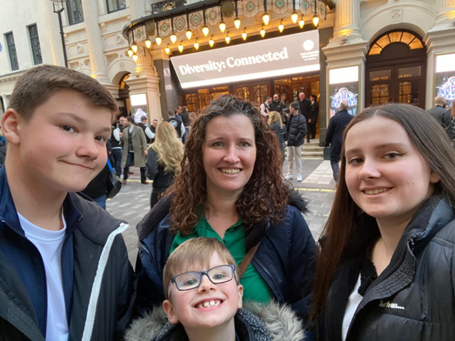

**Complimentary tickets for the hit show**

**Diversity Connected**

Our charity received tickets from the sensational dance group Diversity, which we distributed to our NHS staff members. At the end of the show, Ashley Banjo thanked the crowd for all their support and gave a special shoutout to NHS staff saying, “We cannot thank you enough, for all your hard work”. Our charity was pleased that everyone invited had a fantastic night, it was great knowing that we were able to treat staff and put smiles on their faces.

The lovely ladies from [Romford Embroiderers](https://www.facebook.com/romfordembroiderers?__cft__%5b0%5d=AZUXN-d-GSmu4VppiY9ZJoo4mOs6_2bsZ0Am2Vk7v95d84MCQugbyU5nYRNnaTz0yIRCyQdj21Ox96aEfUQIMebWacYjpZEsxb2HxPumPAcVgfSZ3ssntMo3jkjy8d8chP98mSNXNp6odyTPnsW7L8lAJoPS1G3CNGe8hZ43rTFWjQXHpn_zXMkaeyT7MkFsbwU&__tn__=-%5dK-R), kindly gifted us with a display mural. The fabulous artwork features embroidery patterns made during the COVID-19 lockdown. Each section has been carefully created and tells its own story, it’s fascinating to see how much time and effort was put into designing each piece. We are so grateful for the lady’s dedication to completing this mural during such a difficult period.

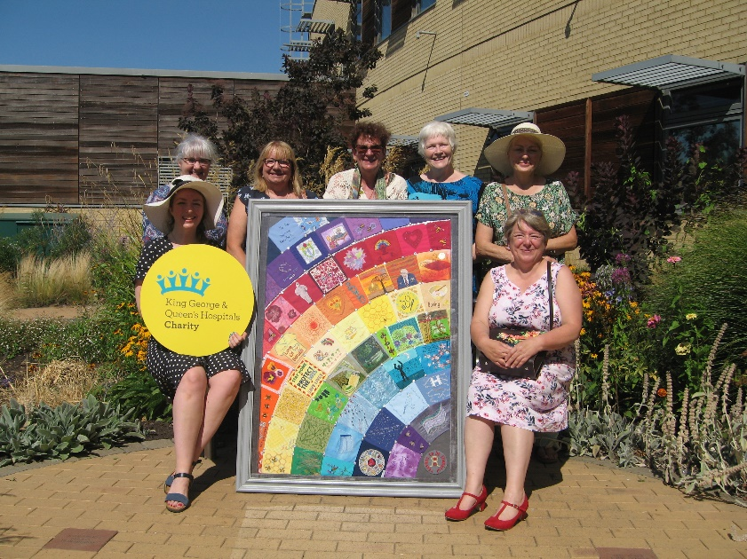

**Romford Embroiderers**

Sarika Pabari visited our charity with a generous donation of toys and arts and crafts for our children’s wards. Sarika had just started her first job and promised herself that her first pay cheque would be used to purchase goods for the children in our hospitals. We were blown away by Sarika's lovely gesture!

When asked why she chose to do this selfless act, she said: "Children in hospitals are going through such terrible illnesses, at no fault of theirs. I wanted to give them a reason to smile again”.

**Sarika Pabari with some of her gifts**

Sarika added: "Giving back to your local hospital’s charity is important, everyone should play their part”.

**Future plans…**

We have work to do around aligning our available funds to Trust needs and reducing the number of accounts we hold to streamline administration.

Getting the word out about our work, what we have achieved, and future projects for our hospitals, involves better promotion. In the coming year, we will produce quarterly newsletters, available in our hospitals, and on all social media platforms. We will launch our own stand-alone charity website, which will be easier to keep updated, allowing people to donate to the charity directly, to an area of their choice. We will also be working with our Trust to promote the charity visibility in the hospital environment.

We will introduce more events, work more closely with corporate sponsors, and launch a grateful patient income line within the hospital.

There is a lot of work to do, but we are a creative and resilient team, and ready for the challenge.

**Administrative details**

|  |  |
| --- | --- |
| **Registered address:**  King George & Queen’s  Hospitals Charity  Queen’s Hospital  Rom Valley Way  Romford RM7 0AG  01708 435000 x 4261 | **Office address:**  King George & Queen’s  Hospitals Charity  210 South Street  Rom Valley Way  01708 435000 x 4261 |
|  |  |

Charity registered in England and Wales. Registration number: 1059455.

**Trust Board Membership during 2022-23**

The hospital Trust has been the Corporate Trustee of the Charity since 27 November 1996.

|  |  |
| --- | --- |
| **Trust Board Membership** | |
| **Chair** | |
| Rt. Hon. Jacqui Smith | Chair – Barts Heath and BHRUT |
|  |  |
| **Non-Executive Directors** | |
| Mr Mehboob Khan | Non-Executive Director Vice Chair |
| Ms Joan Saddler OBE | Non-Executive Director till 30th June 2022 |
| Professor Anthony Warrens | Non-Executive Director till 30th June 2022 |
| Ms Susan Lees | Non-Executive Director |
| Mr Mark Caulfield ** | Non-Executive Director from 1st August 2022 |
| Ms Kathy McLean ** | Non-Executive Director from 1st August 2022 |
| Ms Marta Phillips | Non-Executive Director from 16th May 2022 |
| Ms Lesley Seary ** | Non-Executive Director |
|  |  |
| **Associate Non-Executive Directors** | |
| Ms Ruth Crowley | Associate Non-Executive Director |
| Ms Caroline Roberts | Associate Non-Executive Director |
| Ms Jackie Westaway | Associate Non-Executive Director until 31st August 2022 |
| Mr George Wood | Associate Non-Executive Director until 30th April 2022 |
|  | |
| **Executive Directors** | |
| Mr Shane DeGaris | Group Chief Executive – Barts Health and BHRUT from 1st August 2022 |
| Mr Matthew Trainer | Chief Executive (BHRUT) and Deputy Group Chief Executive (Barts Health and BHRUT) |
| Mr Ben Morrin | Deputy Chief Executive till 5th June 2022 |
| Ms Mamta Vaidya | Chief Medical Officer from 16th May 2022 |
| Mr Justin Daniels | Acting Chief Medical Officer till 16th May 2022 |
| Mr Nick Swift | Chief Financial Officer |
| Mr Michael Gilham | Director of Finance |
| Ms Kathryn Halford OBE | Chief Nurse |
| Mr Peter Hunt | Director of Communications & Engagement |
| Mr Richard Pennington | Acting Chief Operating Officer – Elective till 2nd July 2022 |
| Ms Aleksandra Hammerton | Acting Chief Operating Officer, Non-Elective till 2nd May 2022 |
| Ms Remi Odejinmi | Director of Equality, Diversity and Inclusion till 30th June 2022 |
| Mr Alan Wishart | Director of Workforce |
| Ms Janine La Rosa | Chief People Officer from 10th November 2022 |
| Ms Caroline Van Luttmer | Emergency Pathway Improvement Advisor from 9th May 2022 |

***\*\**** *Appointed to the boards of both Barts Health and BHRUT*

**Charitable Funds Committee Members during 2022-23 (External)**

George Wood Charity Chair

Carol Madeley Charity Member

Dione Rogers Charity Member

Niki Eves Charity Member

Sue Williams Charity Member

**Charitable Funds Committee Members during 2022-23 (Internal)**

Nick Swift Chief Finance Officer

Tracey Thorne Chief Nursing Information officer

Lynda Head Head of Fundraising

|  |  |
| --- | --- |
| **Bankers:**  Barclays Bank plc  Romford Group 9  Leicester  LE87 2BB | **Investment Managers:**  Cazenove Capital  1 London Wall Place  London  EC2Y 5AU |
|  |  |
| **External Auditors:** |
| Johnsons, Chartered Accountants |
| |  | | --- | | Ground Floor | | 1‑2 Craven Road | | London | | W5 2UA | |

**Corporate Trustee’s report**

This report seeks to provide the public with an overview of King George & Queen’s Hospitals Charity (and may be referred to as the Charity for ease of reference within this report), commencing with the activity of investments followed by the reference and structure of the Charity and its governance and management, then concluding with risk management, policies and the Charity’s going concern status.

The Trustee Act 2000 specifies that trustees should implement the same duty of care as if they were investing for themselves and, to ensure that the requirements of the Act are met, our investment managers, Schroders (operating under Cazenove), are authorised to freely buy and sell stocks and shares quoted on a recognised Stock Exchange. The performance of the investments is monitored regularly and reported monthly. This can also be accessed on-line daily as required.

The balance in the investment portfolio has dropped, due to a fall in the market value of the shares held as of 31 March 2023 and the Charity carried forward unrealised losses on shares is reported as (£175,357).

The four properties held were also revalued, and a gain of £260,000 was recorded.

The Annual Report and Accounts for the year ended 31 March 2023 have been prepared by the Corporate Trustee in accordance with the Statement of Recommended Practice (FRS102) – “Charities SORP (FRS 102)” second edition, issued in October 2019.

To assist the reader, the notes to the accounts accompany the Statement of Recommended Practice and the Balance Sheet and show further detailed information. The Statement of Financial Activities incorporate the investment managers’ cost within the Raising Funds heading and governance costs are incorporated within the Expenditure on Charitable Activities heading but are identified clearly in the notes accompanying the financial statements.

The financial statements include all the separately established funds within the Barking, Havering and Redbridge University Hospitals NHS Trust Charity Fund. Both the Annual Report and Accounts are prepared with the intention of informing the reader about the Charity and, in particular, the financial activities which are consistent with the Annual Accounts that are prepared from the records maintained.

**Reference and Structure of the Charity**

Barking, Havering and Redbridge University Hospitals NHS Trust is one of the largest acute hospital trusts in England and has under its administration King George and Queen’s Hospitals, as well as services within Barking Hospital and other satellites.

The Charity, registered charity number 1059455 and entered on the Central Register of Charities on 27 November 1996, has the working title of King George and Queen’s Hospitals’ Charity.

The Charity maintains a combination of unrestricted funds that were established “for any charitable purpose or purposes relating to the NHS” and benefits any one of our hospitals in numerous ways, and funds which are restricted by income and expenditure to enhance the services of their relevant hospital or speciality.

Within each of the subsidiaries are held a number of individual funds that represent specific wards, departments and specialist areas. There also exists a pooling scheme that combines the investments and monies belonging to the above funds to maximise income for the Charity.

**Summary of how main activities support charity’s purpose**

The Trust employs over 8,000 staff who treat thousands of patients every year. Some of the hospital’s patients have life-limiting or life-threatening conditions or rare, complex and serious illnesses. Our Charity’s main objective is to engage in fund raising to help support our staff and patients to have the best experience in the hospital under some of the most difficult circumstances.

Our strategic aim is to fundraise to give seriously ill patients the chance of a better future, including the provision of the most up-to-date medical equipment, fund support services for patients and their families, and support essential refurbishment of the staff areas.

The income of the Charity is made up of voluntary income including donations and legacies, fundraising activities and investment income. These monies are applied to enhance the services provided within the NHS Trust for patient welfare, staff welfare, research and general charitable hospital purposes, in accordance with the objectives of the Charity. The Trust has a policy of issuing an official receipt and letter of acknowledgement to all known donors irrespective of the value, unless the donor requests otherwise.

**Public Benefit Statement**

The Corporate Trustees confirm that they have paid due regard to the Charity Commission’s general guidance on public benefit. The Charity exists to benefit the patients and families of Barking, Havering & Redbridge Hospital Trust. Our grants are structured to ensure that the money raised is used to the best effect, to support the hospital’s work and is in line with donors’ wishes and the Charity’s mission and objectives.

The Charity does not provide facilities directly to the public but provides them to the hospital and in so doing, the patients of the hospital. Grants made to the hospital provide a benefit to the services the hospital provides and are available to all who are entitled to NHS treatment based on need.

**Structure, Governance and Management**

**Nature of Charity’s governance document**

Good governance enables and supports the Charity in complying with relevant legislation and regulation. It also promotes attitudes and a culture where everything works towards fulfilling the Charity's vision. Over the past few years, we have firmly embedded high standards of governance into all our activities, including how we fundraise, and we are committed to demonstrating exemplary leadership and governance.

As an associate of BHRUT (Barking Havering & Redbridge University Hospital NHS Trust), the Charity follows the Trust’s established Standing Financial Instructions (SFIs) and Scheme of Delegation (SoD) as far as permissible, to ensure the application of appropriate governance in all financial and operational matters.

The Trust Board holds overall responsibility for ensuring good governance. The Corporate Trust Board is supported in this by the Audit, Risk & Assurance Committee which focuses on oversight, scrutiny and governance matters related to regulation and reputation, legislative compliance and non-financial risks. The Board is also supported by the Finance and Investment Committee, with responsibility for scrutiny of all financial matters.

A Charitable Funds Committee (CFC), chaired by an external member, has also been established with responsibility for day-to-day operational decisions and governance matters. This committee reports to the Trust Board as Corporate Trustee. The Committee meets every other month in the year, providing a framework to ensure the Charity maintains an appropriate level of governance and compliance across its operational activity and business.

Throughout the year, the Charity continued to keep abreast of changes in legislation and regulation both within the Charity sector and wider, noting consultations issued by the Charity Commission and the Gambling Commission as well as the Government Department for Business, Energy and Industrial Strategy (BEIS) Consultation on Restoring Trust in Audit and Corporate Governance.

Non-Executive Members of the Trust Board are appointed by NHS England, and Executive Members of the Board are subject to recruitment by the NHS Trust Board. Members of the Trust Board and the Charitable Funds Committee are not individual trustees under charity law but act as agents on behalf of the Corporate Trustee.

Newly appointed members of the NHS Trust Board are supplied with an induction pack and the Charity follows the guidance of the Charity Commission to produce an induction pack for newly recruited members of the Charitable Funds Committee. The pack includes copies of the Charity’s annual report and accounts, minutes of previous meetings, a copy of the Charity’s Model Declaration of Trust and a copy of the Charity Commission’s publication CC3 – “The Essential Trustee: what you need to know”, as well as other leaflets, website, and intranet references. A guided tour of the NHS Trust’s facilities and any additional training that their role, or roles, may require is also offered.

The Charity is also a member of NHS Charities Together which runs regular conferences for trustees, fundraisers, and accountants. The accounting records and day-to-day administration of the funds are handled by the Charitable Funds Accountant, King George and Queen’s Hospitals Charity, Finance Department, Queen’s Hospital, Rom Valley Way, Romford RM7 0AG.

Key personnel and staff within the Charity, follow a remuneration package set by the government for NHS staff, and are placed on a banded pay scale according to their role and responsibilities.

**Corporate Trustees**

The Charity has a Corporate Trustee: The Barking Havering and Redbridge University Hospitals NHS Trust. The members of the NHS Trust Board who served during the financial year are noted on pages 21 - 22. The NHS Trust Board devolved responsibility for on-going management of funds to the Charitable Funds Committee that administers the funds on behalf of the corporate trustee. The names of members who served during the financial year are also noted on page 22 of the Annual Report and Accounts.

The Charitable Funds Committee include four external members (one being the Chair of the Charity) who have been enlisted by the Corporate Trustee. Members are enlisted to give a good mix of appropriate professional skills e.g., medical, finance, fundraising and investment. Three of the four members give their time freely and only one member received paid remuneration in an advisory capacity in the year. There have also been minimal member expenses incurred within this period.

**Recruitment of Charitable Funds Committee members for administrative purposes**

The Charity follows the Trust’s established recruitment policy and guidance to ensure a fair and robust recruitment and selection of members.

The Charity’s members are appointed for their relevant individual skills and experience. Members are appointed for a fixed term, with eligibility for reappointment at the end of their term, where appropriate.

Members with specific skills and experience can also be appointed as volunteers to work with the Trustees on Board committees to increase the expertise available.

An induction programme is provided for members on appointment and Charity Commission guidance is shared. The induction programme includes meeting with the Chief Executive, where appropriate, Head of Fundraising, Chair of the Charitable Funding Committee to obtain an overview of the Charity’s activities and key issues. In addition, new members are also offered a tour of the hospital (when safe to do so) and meet with any staff, where appropriate to obtain an understanding of current issues. They are also provided with a range of documentation including access to previous CFC meeting papers and minutes.

Access to training is provided throughout the term of office.

Members are required to disclose all relevant interests and register them with the Corporate Trustee and withdraw from decisions where a conflict of interest arises. All related parties, if applicable, are disclosed in note 16 to the accounts.

**How the Charity makes decisions**

The Charitable Funds Committee (CFC) meet every other month, (minimum 4 times a year) to review the position of the Charity, and to decide upon any funding applications received that are over £1000. The CFC will establish whether the request for Charity funding is a worthy cause for the donations received and confirm it is not something the hospital Trust should be paying for. Delegation limits for approval are followed according to the Trust’s Scheme of Delegation below. All funding applications must be signed off by the directorate’s Divisional Manager or Director, the Trust’s Finance Manager and if over £1,000, the Charitable Funds Committee.

|  |  |  |
| --- | --- | --- |
| **REFERENCE DOCUMENTS** | **DELEGATED MATTER** | **AUTHORITY DELEGATED TO** |
| 6.SFIs Section 17 | **Expenditure from Charitable/Endowment Funds** | |
| Terms of Reference for Charitable Funds Committee as approved by the Trust Board | Up to £10k | Fund holder  + Charity Finance  Manager/Accountant  + Head of Fundraising |
| £10,000 - £50,000 | Fund holder  + Charity Finance  Manage/Accountant  + Head of Fundraising  + Charity Trustee Member |
| £50,000 up to £200,000 | Committee |
| £200,000 plus | Committee + Trust Board |
| **General Purpose Fund – Unrestricted Funds** | |
| Up to £1k | Head of Fundraising |
| Up to £5k (if outside budget) | Charity Director and Chair of Committee |
| Over £5k | Charity Committee |

The day-to-day decisions regarding the Charity, are undertaken by the Head of Fundraising and the financial decisions by the Charity Accountant. Any key decisions will be referred to the Charity Chairman, and the Charitable Funds Committee members.

**Key Management Personnel**

Along with the members attending the Charitable Funds Committee, other members consist of staff representatives (in accordance with the Charity’s Terms of Reference), the Charitable Funds Accountant and Head of Fundraising. The fundraising and administrative staff are employed by the Barking, Havering & Redbridge University Hospitals NHS Trust and their salaries are paid by the Trust. Remuneration is reviewed annually and is increased in accordance with the nationally agreed increases to their pay scale. Staff management costs can be found in note 18 to the accounts.

**Risk Management**

The members have considered the major risks to which the Charity is exposed and identified three major risks that have been acknowledged and arrangements have been put in place to mitigate those risks.

**Risk 1: Fall in investment returns**

The most significant risk which the Charity is exposed to is the possible loss arising from the fall in value of investment shares and the level of reserves affected by such losses. The Charitable Funds Committee have reviewed the system and agreed that unrealised gains and losses are to be distributed to the fund accounts in the event of future market instability and to ensure they are not spent by fund holders without careful consideration by the Charitable Funds Committee. Risks are further mitigated by retaining expert investment managers and having a diversified portfolio and making use of benchmarking information when reviewing the portfolio.

**Risk 2: Future levels of income**

Another risk is a reduction in the levels of income. The Charity is reliant on donations and sufficient cashflow to be able to make grants to our NHS body, to enhance the services provided by the NHS. The Charitable Funds Committee (CFC) members and the Corporate Trustee recognise the impact that the pandemic has had on our community and the general population over the past three years.

In consideration of these risk factors, the fund accounts are carefully monitored, and expenditure is only permitted when it is seen that an account has sufficient funds to support expenditure in accordance with its objectives and whereby there is sufficient cashflow to grant the request at that time. Authority spending levels are strictly set with an account manager requisitioning orders of no more than £250 without prior approval from the Charitable Funds Accountant or the Head of Fundraising. Any expenditure exceeding this amount but less than £1,000 requires the approval of a Divisional Manager or equivalent, with any outgoings greater than £1,000 sanctioned by the Divisional Director and the approval of the Charitable Funds Committee.

The Charitable Funds Committee receives income and expenditure reports together with the latest Statement of Financial Activities and Balance Sheet during their bi-monthly meetings. This is to review the Charity’s performance as part of the risk management process and ensures there are no unforeseen calls on reserves. Where accounts have been shown to be inactive or obsolete, the Committee make a decision to close these accounts and transfer the funds to another clinical service caring for patients/service with the same type of clinical need.

The members discuss regularly with the Fundraising Team the income objectives and whether trajectory figures are keeping in line with expectation. Should income start to fall the members would expect the Fundraising Team to commence a new approach with fresh income lines and to delay some non-essential expenditure to protect cashflow/funds.

**Risk 3: Future levels of salary liabilities**

Following the 2022 audit and the recharge of salary costs back to the charity, the Trust has now become a major creditor to the charity with a debt of over £1 million owed. To try to mitigate this liability, the Charity is looking to sell one house (property asset) for around £700k, to offset the debt owed.

**Financial Review**

The Charity has had another challenging year of fundraising.

Total income increased by £63k from £583k (2021/22) to £646k (2022/23). The increase in the year can be attributed to Income from the recommencement of courses, totalling £62k.

The value in the share investment assets as at 31 March 2023 is reported as £1,989k, which represents 8% (£175k) decrease compared to 2021/22 (£2,164k). The stock market shares are maintained by our fund managers, Cazenove Capital who have diversified the portfolio held by the Charity, to obtain the highest yield possible.

Total expenditure increased by £152k from £676k (2021/22) to £828k (2022/23). The increase is mainly attributable to operational and governance costs of raising funds.

On the balance sheet, total funds held have decreased by £97k from £3,641k (2021/22) to £3,545k (2022/23). This is mainly due to an increase in operational costs.

Following the 2022 audit, the charity staff operational costs of £916k from the previous 3 years and a £350k secondment to the Trust for non-charitable activities were applied. This has resulted in the Trust becoming a creditor to the Charity for £566k as at the end of 2022. The operational costs recharged by Trust for 2023 is £367k. The operational costs amount payable by Charity to Trust at year-end is increased to £945k.

Due to the continuing impact of Covid over the past 3 years, the Charity reviewed its current strategy and replaced this with an interim two-year strategy which commenced in 2021 through to 2023.

The team have had to find new and more innovative ways of raising funds, utilising various online platforms, whilst engaging with the community to do things in the name of the NHS. Some examples of this are Pennies from Heaven and the Christmas Bauble Appeal.

More grant applications were also made this year to NHS Charities Together, and whilst this still was the ‘go to’ charity for donations throughout the pandemic, strict guidelines have been followed to access funds for the benefit of patients and staff wellbeing. The Charity have been a driving force behind a Techno Vols project to help the elderly, frail and vulnerable get access to technological equipment to ease the burden of isolation at home.

As this financial year has progressed, and the impact of Covid has lessened a new way of working has replaced the old-style format of fundraising, with the charity becoming more streamlined and electronic. The Charity’s online presence will continue to expand and grow, allowing the team to look to the future with surety and continue searching for more innovative ways and means of fundraising.

The Charitable Funds Committee (CFC) members and the Corporate Trustees continue to monitor the factors which could have a broader implication on the Charity’s growth, by holding bi-monthly board meetings, and discussing the political, economic, social, and technical aspects that are current concerns, and how this will affect the Charity’s ability to grow. The Charity has already reassessed its growth strategy for the next year in consideration of current Government regulations and will continue to monitor these trends bi-monthly at the Charitable Funds Committee meeting.

**Investment Policy**

The Corporate Trustee and CFC members’ investment objectives are to create sufficient income and capital growth to enable the Charity to carry out its purposes consistently year by year, with due proper consideration for future needs, and if possible, enhancement of the value of the invested funds whilst they are retained. This also includes rental incomes received from let properties.

The CFC members aim to support a strong future by assisting in the long-term prospects of Barking Havering and Redbridge University Hospitals NHS Trust by supporting research, education, new equipment, staff and patient benefits, and environmental improvements.

“The aim of the Charity is not to subsidise the NHS Core Services, but to listen to the concerns, ideas and innovations from the hospital user, including staff and patients. Our aim is to make our hospitals even better”.

A key part of the Charity’s objectives remains earning optimal returns on already prudently invested funds in a broad range of fixed interest securities and equities which are quoted on a Recognised Investment Exchange and Unit Trusts, which are authorised under the Financial Services and Markets Act 2000. The members reserve the right to exclude companies that carry out activities contrary to their aims, or from holding investments which damage the Charity’s reputation and aim to minimise investment in tobacco or alcohol as defined by companies with more than 20% of their turnover in these activities.

The investment policy requires that all investment income be retained in liquid form in order for this to be made available without the risk of having to sell shares at a time when shares might be volatile. This will remain the case unless the Charity receives any large unrestricted cash funding that is surplus to foreseeable needs, in which case this would be invested prudently for maximum return on investment.

**Investment Property Rented to Third Parties**

The Charity officially inherited 4 properties in June 2021, which will be held to earn rental income or for capital appreciation or for both. The houses were left to Oncology and as of 31 March 2023, two have tenants in them and two are empty. They have been included in the Balance Sheet for the current year.

**Accounting Estimates and Judgements**

For the purpose of this annual report, the valuations given to the 4 properties were obtained on 31 March 2023, totalling £1.65 million. These valuations were carried out by a qualified RICS valuer, Andrew Chater & Co, Chartered Surveyors, of 35 Great Nemes Chase, Emerson Park, Hornchurch, Essex, RM11 2PS. The company was recommended by our current lettings’ agent HML Lettings Ltd.

**Objectives and Activities & Strategic Plan**

Aims and what the Charity seeks to tackle through its activities:

The Trustee has agreed key objectives for the management of the Charity towards achieving its goals:

* Annual Accounts should be independently audited and reported;
* Investment performance should be regularly reviewed;
* Charity Commission returns must be submitted by the required date;
* All expenditure of the Charity should support the aims of BHR University Hospitals NHS Trust;
* The Charity will commit any unallocated reserves to support any additional developments, where appropriate;
* The Charity will invest in fundraising to proactively seek new income;
* The Charity will set realistic fundraising targets – at present 18% growth per year, notwithstanding setbacks attributing to Covid and associated regulations inhibiting fundraising activities.

Achievements of aims to further its legal purposes:

“To hold the trust fund upon faith to apply the income, and at their discretion, so far as may be permissible, the capital for any charitable purpose relating to the National Health Service**.”**

To further the achievement of this legal purpose, the Charity undertakes several activities. These include the establishment and support for any activities that would improve patient care and achieve the Charity’s aim through application for funding and subsequent approvals. The Charity also employs staff to engage in various fundraising activities to ensure funds are available to pursue the Charity’s legal purpose both to the hospital and the Charity Commission guidelines. The Charity also engages, through the use of experts in the field, investments to create sufficient income and capital growth to enable the Charity to carry out its purpose.

Strategies for achieving its stated aims and objectives

Following the pandemic, the Charity is now working to a revised two-year strategy plan 2021-2023. Within the next two years, the Charity’s strategic plan and aim is to become a well-recognised, professional and successful Charity of choice for local people in Barking, Havering and Redbridge. In line with the hospital’s core PRIDE values, (Passion, Responsibility, Innovation, Drive, Empowerment), we aim to have a responsible presence, effective process, outstanding management and grow and retain our donors.

The Charity aims to have well-supported annual, innovative, successful and inspirational events and campaigns, to engage people of all ages and from all areas of the community.

The Charity aims to undertake several activities to fulfil its aims and objectives. Specifically, it will:

* Increase level of awareness through promotion both internally, externally and on social media
* Engage staff and volunteers willing to promote the Charity as fund holders and ambassadors across the Trust
* Proactively identifying, defining and managing how charitable funds are spent in accordance with Trust and Charity objectives and priorities; and
* To maintain a strong relationship with other associated fundraising Trusts i.e., East London ICS and NHS Charities Together (NHSCT).

The Charity actively creates events, challenges, and campaigns to encourage the local community to help raise funds and support its local hospitals. One step towards this was the introduction of an ‘Ambassadors Group’ in 2017/18, consisting of local individuals and businesses who have adopted us as their Charity of choice. They work collaboratively to raise funds at their own events, and include local banks, associations, businesses and groups.

Criteria or measures for assessing success

The measure for the Charity’s success will be proven from the statistics produced year on year, showing its performance, fundraising accomplishments along with completed projects.

The Charity has several metrics it uses in measuring the accomplishment, or otherwise, of its fundraising and expenditure activities. These are included in monthly management accounts reports which are discussed at the bi-monthly Charitable Funds Committee meetings. The key metrics are:

* Measurement of operational staff costs against income generated
* Income target/budget against actual income (monthly, quarterly and yearly)
* Various lines of expenditure (including pay and non- pay) reports and comparisons to previous periods
* Investment reports on fluctuations on the stock market for gains and losses every quarter; and
* Monitoring cash and working capital balances on quarterly basis, and also compared to previous years

Short term and long term aims and objectives

Following another year of uncertainty and new methods of raising funds were introduced, there continues to be a steady evolvement of the Charity. Both short and long-term objectives were revised, and whilst some were put on hold, the safety of both staff and the public has always come first. That said, both existing and the reintroduction of campaigns were created this year to help the patients in the long term and those affected by Covid-19.

Social Investment

The Charity does not undertake in any social investment.

Grants received

The Charity received a grant from NHS Charities Together (NHSCT), and other community fund groups this year. The funds from NHS Charities Together (NHSCT) were originally raised by the walk taken on by Sir Captain Tom Moore, and various other donations from the public. The Charity was then invited to apply for funding.

Volunteers

All volunteers are managed and serviced by the hospital’s Volunteer Services Department. The Charity has dedicated volunteers helping with charity projects such as the Lavender Garden.

In setting the objectives and activities of the Charity, the Corporate Trustee and members have given due consideration to the Charity Commission’s published guidance on public benefit.

**Achievements and Performance**

The Charity staff and CFC members have paid due regard in deciding what activities the Charity has been able to create during the year and have also continued to support a wide range of charitable purposes.

For specific grants the Charity identified four key areas where they considered funds should be spent. They are the support of medical equipment, research and training, technology and information, comfort and the environment.

Some of the items bought this year are as follows:

|  |  |
| --- | --- |
| Medical Equipment | Purchase of 2 Accuveins and viewing system |
| Research and Training | Re-introduction of various staff courses – NLS, MOET, ATLS, Breast Away Day, JAG Colonoscopy, TESS courses to name a few. |
| Technology and Information | iPads for Children’s wards, 16 x RITA devices |
| Comfort and the Environment | Lavender Garden maintenance and upkeep, refurbishment of children’s sensory room, LED light boxes, various children’s toys, Ryno Lounge Chair for  A & E |

During 2022/23 the Charity’s contribution to the Trust fell by £138k; this can mainly be attributed to a drop in requests from staff from their charity fund pots. The Charity’s contribution in 2022/23 was £243k a drop from £381k in 2021/22.

The original 5-year strategy begun in 2017 which was expected to increase the Charity’s income by 18% year on year, with the aim of achieving £1 million by 2021, has since been superseded with an interim two-year plan, in response to the Covid outbreak.

**Reserves Policy**

The Corporate Trustee have a policy of wisely spending the charitable funds entrusted to their care. The Charity Policy states that the funds must be spent for the purposes for which they were received and where they give the most benefit to the hospital user. Our aim is not to allow funds to accumulate. The Charity expects the Divisions to deliver requests for projects which fit the criteria of the Charity for expenditure.

Our target for reserves this year is to retain the cash equivalent of at least 3 month’s operational expenditure, (£100k) to cover the relevant period’s support costs. The reserve is made up of cash already held with the Charity’s banker, Barclays Bank Plc, and have been noted within cash and cash equivalents. Further funds can be released from investments if necessary.

**Future Plans**

The Charitable Funds Committee members and the Corporate Trustee encourages Directorate fund holders and their management teams to provide spending plans for each speciality charitable fund. The fund holders have delegated authority to use the funds in the most beneficial way for their specialism.

Plans for the next twelve months will be determined by the requests received from each Division but will expect to follow areas of spend such as:

* Enhancement of patient experience
* Staff training and conferences
* Purchase of enhanced medical equipment
* Support research projects
* Providing a better environment
* Staff wellbeing

The Charity is in the final year of a 3-year commitment to purchase a £1,525,000 Da Vinci Robotic Arm, i.e. fully settled in FY2022/23. the Da Vinci has been a great addition to surgery at Queen’s Hospital. It delivers less invasive surgery, shorter patient stays in hospital, faster rehabilitation and raises the standard of care for patients undergoing surgical procedures.

**Going Concern**

The financial statements have been prepared on a going concern basis which the Corporate Trustees consider to be appropriate for the following reasons:

* The Corporate Trustee has prepared cash flow forecasts for a period of 12 months from the date of approval of these financial statements which indicate that, taking account of reasonably possible downsides on its operations and its financial resources, the Charity will have sufficient funds to meet its liabilities as they fall due for that period.
* The path out of the Covid-19 pandemic continues to impact on the way the Charity can generate income in terms of events, traders and general community fundraising. Although the charity has found new ways of raising funds through various online fundraising portals, donations are still below the expected levels. NHS Charities Together continues to provide another means for claiming grant funding, and this has helped to some extent.
* Although most risks can be mitigated with other fundraising methods, the team has looked to the future and come up with more innovative ways and means of fundraising. Our liquidity is further managed through the management of cost base, with our expenditure on charitable activities flexible to match the levels of income received.
* The Corporate Trustee encourages the Charity to hold reserves equivalent to 3 months’ working costs, to ensure the continuity of activities should there be a major reduction in income. This is to meet fluctuations in receipts or payments, meeting specific future needs, or set money aside to cover events or situations that may happen. The Charity could sell one of its investment properties, or the shares held on the stock market to increase the cash on an ongoing basis if it were to fall into harder times financially.

Consequently, the Corporate Trustees are monitoring the Charity so that it will have sufficient funds to continue to meet its liabilities as they fall due for at least 12 months from the date of approval of the financial statements and therefore have prepared the financial statements on a going concern basis.

**Fundraising Statement**

“Section 162a of the Charities Act 2011 requires Charities to make a statement regarding fundraising activities. Although the Charity does not undertake national widespread fundraising from the general public, the legislation defines fund raising as “soliciting or otherwise procuring money or other property for charitable purposes.” Such amounts receivable are presented in our accounts as “voluntary income, or donations” and includes legacies and grants.

In relation to the above we confirm that in the year under review, the charity engaged the services of a professional fundraiser to solicit funds to supplement its fundraising activities. The day-to-day management of all income generation is delegated to the executive team, who are accountable to the Corporate Trustee.

The Charity also works in partnership with external individuals who wish to fundraise independently of the Charity, by participating in external challenges and events at their own risk. The charity will continue to form alliances with them for key priority areas, such as cancer services and children services, sharing talent, knowledge and expertise in order to achieve greater impact and maximise the benefits to the hospital.

Our Trust serves three London boroughs with a multi-cultural and diverse population. We mirror and adhere to the Equality, Diversity and Inclusion (EDI) strategy and policy set out by our Trust which is compliant to the Human Rights Act 1998 and Equality Act 2010. As a non-discriminatory charity we are committed to operating an inclusive environment for both our staff and stakeholders that fully represents every culture, background and viewpoint, and we ensure every voice is heard.

The Charity has also partnered with AGE UK HBR, (Havering, Barking & Redbridge) over the past year in the Techno Vols project, to alleviate the feeling of isolation in our elderly patients being discharged from the hospital and going back into the community. The Charity tries to ensure they are met with a representative from AGE UK HBR at home that will assist them further in their recovery and to combat loneliness.

The Charity is not bound by any undertaking or by any regulatory scheme, however the Charity is a member of the Charity Commission and complies with their relevant codes of practice.

We have received no complaints in relation to fundraising activities. Our terms of employment always require staff to behave reasonably and with integrity.

Signed by Order of the Corporate Trustee:

Chief Finance Officer (Nick Swift) …………………………….Date… 2024

**Statement of Trustee Responsibilities in respect of the Trustee Annual Report and the Financial Statements**

**Corporate Trustee’s responsibilities**

The Corporate Trustee is responsible for preparing the Annual report and the financial statements in accordance with applicable law and regulations. Charity law requires the Corporate Trustee to prepare financial statements for each financial year in accordance with United Kingdom Generally Accepted Accounting Practice (United Kingdom Accounting Standards and applicable law). Under Charity law the Corporate Trustee must not approve the financial statements unless they are satisfied that they give a true and fair view of the state of affairs of the Charity and of the incoming resources and application of resources, including the income and expenditure, of the Charity for that period.

In preparing these financial statements, the Corporate Trustee is required to:

* select suitable accounting policies and then apply them consistently;
* make judgements and accounting estimates that are reasonable and prudent;
* state whether applicable UK Accounting Standards have been followed, subject to any material departures disclosed and explained in the financial statements; and
* prepare the financial statements on the going concern basis unless it is inappropriate to presume that the charity will continue in business.

The Corporate Trustee is responsible for keeping adequate accounting records that are sufficient to show and explain the Charity’s transactions and disclose with reasonable accuracy at any time the financial position of the Charity and enable them to ensure that the financial statements comply with the Charities Act 2011. They are also responsible for safeguarding the assets of the Charity and hence for taking reasonable steps for the prevention and detection of fraud and other irregularities.

Statement as to disclosure to our auditors

* In so far as the Trustee is aware at the time of approving our Trustee’s annual report: there is no relevant information, being information needed by the auditor in connection with preparing their report, of which the auditor is unaware and
* the Trustee has taken all steps that they ought to have taken to make themselves aware of any relevant audit information and to establish that the auditor is aware of that information.

Signed on behalf of the Corporate Trustee:

Chief Finance Officer (Nick Swift) ………………………..Date …… 2024

**Independent Auditor’s report to the Trustees of Barking, Havering and Redbridge University Hospitals NHS Trust Charity Fund**

**Opinion**

We have audited the financial statements of King George and Queen’s Hospitals Charity (the ‘charity’) for the year ended 31 March 2023 which comprise Statement of financial activities, Balance sheet, statement of cash flows, and notes to the financial statements, including significant accounting policies.  The financial reporting framework that has been applied in their preparation is applicable law and United Kingdom Accounting Standards, including Financial Reporting Standard 102 The Financial Reporting Standard applicable in the UK and Republic of Ireland (United Kingdom Generally Accepted Accounting Practice).

In our opinion, the financial statements:

* Give a true and fair view of the state of the charity’s affairs as at 31 March 2023, and of its incoming resources and application of resources, including its income and expenditure, for the year then ended
* Have been properly prepared in accordance with United Kingdom Generally Accepted Accounting Practice; and
* Have been prepared in accordance with the requirements of the Charities Act 2011.

**Basis for opinion**

We conducted our audit in accordance with International Standards on Auditing (UK) (ISAs (UK)) and applicable law. Our responsibilities under those standards are further described in the Auditor’s responsibilities for the audit of the financial statements section of our report. We are independent of the charity in accordance with the ethical requirements that are relevant to our audit of the financial statements in the UK, including the FRC’s Ethical Standard, and we have fulfilled our other ethical responsibilities in accordance with these requirements.  We believe that the audit evidence we have obtained is sufficient and appropriate to provide a basis for our opinion.

**Conclusions relating to going concern**

In auditing the financial statements, we have concluded that the Corporate Trustee’s use of the going concern basis of accounting in the preparation of the financial statements is appropriate.

Based on the work we have performed, we have not identified any material uncertainties relating to events or conditions that, individually or collectively, may cast significant doubt on the charity's ability to continue as a going concern for a period of at least twelve months from when the financial statements are authorised for issue.

Our responsibilities and the responsibilities of the Corporate Trustee with respect to going concern are described in the relevant sections of this report.

**Other information**

The other information comprises the information included in the trustee’s annual report, other than the financial statements and our auditor’s report thereon. The trustees are responsible for the other information contained within the annual report. Our opinion on the financial statements does not cover the other information and, except to the extent otherwise explicitly stated in our report, we do not express any form of assurance conclusion thereon.

Our opinion on the financial statements does not cover the other information and we do not express any form of assurance conclusion thereon.

In connection with our audit of the financial statements, our responsibility is to read the other information and, in doing so, consider whether the other information is materially inconsistent with the financial statements, or our knowledge obtained in the audit or otherwise appears to be materially misstated. If we identify such material inconsistencies or apparent material misstatements, we are required to determine whether this is a material misstatement in the financial statements or a material misstatement of the other information. If, based on the work we have performed, we conclude that there is a material misstatement of this other information, we are required to report that fact.

We have nothing to report in this regard.

**Matters on which we are required to report by exception**

We have nothing to report in respect of the following matters in relation to which the Charities (Accounts and Reports) Regulations 2008 require us to report to you if, in our opinion:

* The information given in the financial statements is inconsistent in any material respect with the Corporate Trustee’s report; or
* The charity has not kept adequate accounting records; or
* The financial statements are not in agreement with the accounting records and returns; or
* We have not received all the information and explanations we require for our audit.

**Responsibilities of trustees**

As explained more fully in the Corporate Trustee’s responsibilities statement, set out on page 40, the Corporate Trustee is responsible for the preparation of the financial statements and for being satisfied that they give a true and fair view, and for such internal control as the trustees determine is necessary to enable the preparation of financial statements that are free from material misstatement, whether due to fraud or error.

In preparing the financial statements, the Corporate Trustee is responsible for assessing the charity’s ability to continue as a going concern, disclosing, as applicable, matters related to going concern and using the going concern basis of accounting unless the trustees either intend to liquidate the charity or to cease operations, or have no realistic alternative but to do so.

**Auditor’s responsibilities for the audit of the financial statements**

We have been appointed as auditor under section 144 of the Charities Act 2011 and report in accordance with regulations made under section 154 of that Act.

Our objectives are to obtain reasonable assurance about whether the financial statements as a whole are free from material misstatement, whether due to fraud or error, and to issue an auditor’s report that includes our opinion. Reasonable assurance is a high level of assurance but is not a guarantee that an audit conducted in accordance with ISAs (UK) will always detect a material misstatement when it exists. Misstatements can arise from fraud or error and are considered material if, individually or in the aggregate, they could reasonably be expected to influence the economic decisions of users taken on the basis of these financial statements.

Irregularities, including fraud, are instances of non-compliance with laws and regulations. We design procedures in line with our responsibilities, outlined above, to detect material misstatements in respect of irregularities, including fraud. The extent to which our procedures are capable of detecting irregularities, including fraud is detailed below:

**Extent to which the audit was considered capable of detecting irregularities, including fraud**

We identify and assess the risks of material misstatement of the financial statements, whether due to fraud or error, and then design and perform audit procedures responsive to those risks, including obtaining audit evidence that is sufficient and appropriate to provide a basis for our opinion.

**Identification and assessment of potential risks**

In identifying and assessing potential risks related to irregularities and in identifying and assessing risks of material misstatement in respect of irregularities, including fraud and non-compliance with laws and regulations, we conducted:

* Regular meetings with those charged with governance;
* Enquiries of management, including obtaining and reviewing supporting documentation, concerning the charity’s material policies and procedures relating to: identifying, evaluating and complying with laws and regulations and whether they were aware of any instances of non-compliance relating to the detecting and responding to the risks of fraud and whether they have knowledge of any actual, suspected or alleged fraud; and the internal controls established to mitigate risks related to fraud or non-compliance with laws and regulations;
* Our reviews of the charity’s remuneration policies, and key drivers for remuneration and bonus levels;
* Our assessment of the influence of public officials over the operations of the charity including any material transactions with related parties and key individuals; and
* Discussions among the engagement team regarding how and where fraud might occur in the financial statements and any potential indicators of fraud. The engagement team includes the Audit Director and staff who have extensive experience of working with charities in the same sectors as the charity, and this experience was relevant to the discussion about where fraud risks may arise.

**Risks arising from legal and regulatory frameworks**

We are also required to perform specific procedures to respond to the risk of management override. We also obtained an understanding of the legal and regulatory frameworks in which the charity operates, focusing on provisions of those areas that had a direct effect on the determination of material amounts and disclosures in the financial statements.

We did not identify any material audit matters related to the potential risk of fraud or non-compliance with laws and regulations from our work:

* Reviewing management override of controls;
* Testing the appropriateness of journal entries and other accounting adjustments;
* Assessing whether the judgements made in making accounting estimates are indicative of a potential bias; and
* Evaluating the business rationale of any significant transactions that are unusual or outside the normal course of business.

We also communicated our assessment of the relevant laws and regulations and potential fraud risks to all engagement team members including internal specialists and significant component audit teams, and remained alert to any indications of fraud or non-compliance with laws and regulations throughout the audit.

Because of the inherent limitations of an audit, there is a risk that we will not detect all irregularities, including those leading to a material misstatement in the financial statements or non-compliance with regulation. This risk increases the more that compliance with a law or regulation is removed from the events and transactions reflected in the financial statements, as we will be less likely to become aware of instances of non-compliance. The risk is also greater regarding irregularities occurring due to fraud rather than error, as fraud involves intentional concealment, forgery, collusion, omission or misrepresentation.

A further description of our responsibilities is available on the Financial Reporting Council’s website at: <https://www.frc.org.uk/Our-Work/Audit/Audit-and-assurance/Standards-and-guidance/Standards-and-guidance-for-auditors/Auditors-responsibilities-for-audit/Description-of-auditors-responsibilities-for-audit.aspx>. This description forms part of our auditor’s report.

We communicate with those charged with governance regarding, among other matters, the planned scope and timing of the audit and significant audit findings, including any significant deficiencies in internal control that we identify during our audit.

**Use of our report**

This report is made solely to the Charity’s Corporate Trustee, as a body, in accordance with Part 4 of the Charities (Accounts and Reports) Regulations 2008.  Our audit work has been undertaken so that we might state to the charity’s trustees those matters we are required to state to them in an auditor’s report and for no other purpose. To the fullest extent permitted by law, we do not accept or assume responsibility to anyone other than the charity and the charity’s trustees as a body, for our audit work, for this report, or for the opinions we have formed.

Edmund Cartwright FCCA FMAAT (Senior Statutory Auditor)

for and on behalf of Johnsons Chartered Accountants, Statutory Auditor

London, United Kingdom

**Barking, Havering & Redbridge University Hospitals NHS Trust Charity**

**Statement of Financial Activities for the year ended 31 March 2023**

|  |  |  |  |  |  |  |  |
| --- | --- | --- | --- | --- | --- | --- | --- |
|  | Note | 2022-23  Unrestricted  Funds  £000 | 2022-23  Restricted  Funds  £000 | **2022-23**  **Total**  **Funds**  **£000** | 2021-22  Unrestricted  Funds  £000 | 2021-22  Restricted  Funds  £000 | 2021-22  Total  Funds  £000 |
| **Income From:** |  |  |  |  |  |  |  |
| Donations and legacies | 2 | **391** | **0** | **391** | 149 | 320 | 469 |
| Income from investments (shares) | 2&3 | **88** | **0** | **88** | 24 | 61 | 85 |
| Income from Property Investments | 2 | **26** | **0** | **26** | 0 | 19 | 19 |
| Income from Charitable Activities (Community) | 2 | **76** | **1** | **77** | 1 | 0 | 1 |
| Income from Charitable Activities (Events) | 2 | **44** | **0** | **44** | 0 | 0 | 0 |
| Income from Non-Charitable Activities | 2 | **20** | **0** | **20** | 9 | 0 | 9 |
| **Total income** | 2 | **645** | **1** | **646** | 183 | 400 | 583 |
|  |  |  |  |  |  |  |  |
| **Expenditure On:** |  |  |  |  |  |  |  |
| Expenditure on raising funds (other) |  | **(39)** | **0** | **(39)** | (10) | (5) | (15) |
| Expenditure on raising funds (support costs) |  | **(379)** | **0** | **(379)** | (52) | (136) | (188) |
| Expenditure on charitable activities (other) | 4 | **(308)** | **(2)** | **(310)** | (242) | (177) | (419) |
| Expenditure on charitable activities (support costs) | 4 | **(44)** | **(0)** | **(44)** | (29) | (9) | (38) |
| Expenditure from Property Investments |  | **(56)** | **0** | **(56)** | 0 | (16) | (16) |
| **Total expenditure** |  | **(826)** | **(2)** | **(828)** | (333) | (343) | (676) |
|  |  |  |  |  |  |  |  |
| Net gain/(loss) on investments |  | **(175)** | **0** | **(175)** | 74 | 0 | 74 |
| Net gain on properties |  | **260** | **0** | **260** | 0 | 190 | 190 |
| **Net Gains/Losses movements in funds** |  | **85** | **0** | **85** | 74 | 190 | 264 |
| **NET MOVEMENTS IN FUNDS** |  | **(95)** | **(1)** | **(96)** | (76) | 247 | 171 |
| **Reconciliation of funds** |  |  |  |  |  |  |  |
| Fund balances brought forward | 12.1 | **1,316** | **2,325** | **3,641** | 1,392 | 2,078 | 3,470 |
| **Fund balances carried forward**– restated UR & UR/Designated position following Due Diligence Investigation | 12.1 | **3,473** | **72** | **3,545** | 1,316 | 2,325 | 3,641 |

The notes in pages **50 to 70** form part of these accounts.

**Barking, Havering & Redbridge University Hospitals NHS Trust Charity**

**Balance Sheet at 31 March 2023**

|  |  |  |  |
| --- | --- | --- | --- |
|  | **Note** | **31**  **March**  **2023**  **£000** | 31 March  2022  £000 |
| **Fixed assets:** |  |  |  |
| Tangible Assets (Property) | 19 | **1,650** | 1,390 |
| Investments | 8 | **1,989** | 2,164 |
|  |  |  |  |
| **Total fixed assets** |  | **3,639** | 3,554 |
|  |  |  |  |
| **Current assets:** |  |  |  |
| Debtors | 9 | **3** | 4 |
| Cash and cash equivalents | 10 | **1,251** | 1,289 |
|  |  |  |  |
| **Total Current Assets** |  | **1,254** | 1,293 |
|  |  |  |  |
| **Liabilities:** |  |  |  |
| Creditors: Amounts falling due within one year | 11 | **(1,327)** | (1,204) |
| Deferred income | 11 | **(22)** | (2) |
| **Net current assets** |  | **(95)** | 87 |
|  |  |  |  |
| **Total Assets less current liabilities** |  | **3,545** | 3,641 |
|  |  |  |  |
| **Total Net assets** | 7 & 12.1 | **3,545** | 3,641 |
| **The funds of the Charity**: |  |  |  |
| Unrestricted/Designated income funds |  | **72** | 2,325 |
| Unrestricted income funds |  | **3,473** | 1,316 |
| **Total Charity funds** | 7 & 12.1 | **3,545** | 3,641 |

The notes in pages **50 to 70** form part of these accounts.

Signed …………….Chief Finance Office Date

**Barking, Havering & Redbridge University Hospitals NHS Trust Charity**

**Statement of cash flows for the year ending 31 March 2023**

|  |  |  |  |
| --- | --- | --- | --- |
| **Reconciliation of net income to net cash flow from operating activities** | **Note** | **2022-23**  **Total Funds**  **£000** | 2021-22  Total Funds  £000 |
| **Net income** |  | **(96)** | 171 |
| **Adjustments for:** |  |  |  |
| Gains on investment funds and properties held |  | **(86)** | (264) |
| Dividends and interest from investments | 2&3 | **(88)** | (85) |
| (Increase)/decrease in debtors | 9 | **(1)** | 6 |
| Increase/(decrease) in creditors | 11 | **145** | (153) |
| **Net cash generated from operating activities** |  | **(126)** | (325) |
| **Cash flows from investing activities:** |  |  |  |
| Dividends and interest from investments | 2&3 | **88** | 84 |
| **Net cash generated from investing activities** |  | **88** | 84 |
|  |  |  |  |
| Change in cash and cash equivalents during the year | 10 | **(38)** | (240) |
| Cash and cash equivalents at the beginning of the year | 10 | **1,289** | 1,529 |
| **Cash and cash equivalents at the end of the year** | 10 | **1,251** | 1,289 |

The notes in pages **50 to 70** form part of these accounts.

**Notes to the Accounts**

**1 Accounting Policies**

* 1. **Basis of preparations**

The Charity is a public benefit entity, and the financial statements have been prepared to give a true and fair view and have departed from the charities (Accounts & Reports) Regulations 2008, only to the extent required to provide a ‘true and fair view’. The financial statements have been prepared in accordance with Statement of Recommended Practice (FRS 102) – Charities SORP (FRS102) second edition, issued in October 2019.

The financial statements have been prepared on a going concern basis which the Corporate Trustee considers to be appropriate for the following reasons.

The Corporate Trustee has prepared cash flow forecasts for a period of 12 months from the date of approval of these financial statements which indicate that, taking account of reasonably possible downsides, the Charity will have sufficient funds to meet its liabilities as they fall due for that period.

The pandemic has impacted on the way the Charity has generated income this year, with the continued loss of traders and the slow donations of community collection boxes. However, the Charity has reintroduced some events again, namely the annual charity ball, whilst finding new ways of raising funds through various online fundraising portals and regular giving channels. The generous donations made by the population to NHS Charities Together continued throughout the year and has also provided funds by way of a grant, to reduce the material uncertainty for this year and for the next two years.

Although most risks can be mitigated with other fundraising methods, the slow easing of Covid-19 regulations has allowed the team to look to the future and search for more innovative ways and means of fundraising. Our liquidity is further managed through the management of cost base, but our operational costs and expenditure on charitable activities have not reached the levels of income received.

Consequently, the Corporate Trustee are looking at the different ways the Charity can meet its liabilities, through the sale of its assets, as they fall due for at least 12 months from the date of approval of the financial statements and therefore have prepared the financial statements on a going concern basis.

**Governance costs**: previously, these had been separately analysed on the face of the Statement of Financial Activities, but Governance costs are now classified under Expenditure on Raising Funds on the SOFA. The analysis of support costs, including governance costs, is shown in note 4 and 5.

**Cash and cash equivalents**: Investments held in short term cash accounts are liquid funds and require no period of notice and are now classified as cash and cash equivalents and have been shown as part of cash and cash equivalents on the balance sheet since 1st April 2015. There is no impact on the total funds of the Charity. An analysis of cash and cash equivalents is provided in note 10.

**Investment Property Rented to Third Parties**

The Charity officially inherited 4 properties in June 2021, which has provided a small rental income designated to Oncology. The Charity has duly recognised these investment assets in the Balance Sheet under Tangible Assets (property) for the current year. A RICS Chartered surveyor values the properties at year end, to ensure the correct value of all four properties is recorded in the ledgers. (RICS Appraisal and Valuations Standards, 9th Edition 2014.)

**Accounting Estimates and Judgements**

For the purpose of this annual report, the valuations given to the 4 properties were made on 31 March 2023, totalling £1.65 million. This is a gain of £260k to the 2021/22 valuation of £1.39 million. This can be attributed to an upward turn in the current market value and the removal of one tenant from 74 Sunningfields Road.

Although the upward general market trends for houses continues to outstrip the supply, the value of house prices has remained fairly consistent at the time of valuation, despite various Bank of England base rate increases and general inflation in excess of 10% as at the close of March 2023.

Whilst the Charity considers the methodologies and assumptions adopted in the valuations are supportable, reasonable and robust, these estimated values may differ from the values that could be used on a ready market for the investment.

* 1. **Income (stated as ‘Income From’ on the SoFA)**

a) All income, including donated goods, are included in full in the Statement of Financial Activities as soon as the following three factors can be met:

1. Entitlement – arises when a particular resource is receivable, or the Charity’s right becomes legally enforceable
2. Probable – it is more likely than not that the economic benefits associated with the transaction or gift will flow to the Charity; and
3. Measurement – when the monetary value of the income can be measured with sufficient reliability

**Income from legacies**

Legacies are accounted for according to Charities SORP (FRS 102)" second edition, issued in October 2019, as soon as income is probable, can be measured and entitled. This will be confirmed from the representatives of the estates that payment of the legacy will be made, or property transferred, and once all conditions attached to the legacy have been fulfilled.

Material legacies which have been notified, but not recognised as income in the Statement of Financial Activities are disclosed in a separate note to the accounts with the estimate of the amount receivable (Contingencies Note 15). There were no accrued legacies for 2022/23.

* 1. **Expenditure (stated as ‘Expenditure On’ in the SoFA)**

The funds held in trust accounts are prepared in accordance with the accruals concept. All expenditure is recognised once there is a legal or constructive obligation to make a payment to a third party.

a) Cost of generating funds *(Expenditure on Raising Funds within the SoFA)*

The cost of generating funds is the costs associated with generating income for the funds held on trust. This will include the costs associated with expenses payable for fundraising and investment managers’ fees.

b) Grants payable *(Expenditure on Charitable Activities within the SoFA)*

Grants payable are payments, made to third parties (including NHS bodies) in furtherance of the funds held on trust’s charitable objectives to relieve those who are sick. They are accounted for on an accrual’s basis where the conditions for their payment have been met or where a third party has reasonable expectation that they will receive the grant. This includes grants paid to NHS bodies.

* 1. **Structure of Funds**

Unrestricted income funds comprise of those funds where the donor has not issued a specific request for where the funds should be used. These funds may then be used for any purpose in furtherance of the charitable objectives. Unrestricted funds can include designated funds where a donor may have made a non-binding request, or the members have created a fund for a specific purpose.

Where there is a legal restriction or one imposed by the donor on the purpose to which funds may be used, they are treated as restricted funds.

Funds where the capital is held to generate income for charitable purposes and cannot themselves be spent are accounted for as endowment funds. The Charity had no endowment funds during the financial year to 31 March 2023. Other funds are classified as unrestricted funds.

Funds which are not legally restricted but which the members have chosen to earmark for set purposes are classified as unrestricted designated funds. The major funds held within these categories are disclosed on note 12.1.

* 1. **Fixed asset investments**

Investment of quoted stocks and shares are included in the balance sheet at mid-market price, ex-dividend.

* 1. **Realised gains and losses**

All gains and losses are taken to the Statement of Financial Activities as they arise. Realised gains and losses on investments are calculated on the difference between sale proceeds and opening market value (or date of purchase if later). Unrealised gains and losses on investments are calculated as the difference between market value at the year-end and opening market value (or date of purchase if later).

The Charity processes all losses and gains proportionately against unrestricted and unrestricted/designated funds.

In accordance with the new Statement of Recommended Practice (FRS 102)' - "Charities SORP (FRS 102)" second edition, issued in October 2019, the net gains and losses are shown under the heading for either income or expenditure.

* 1. **Support Costs**

Support Costs relate to operational costs for the charity and are defined as Administration Costs and relate to general overheads and system support costs. These include salaries, bank and investment charges, insurance costs, Just Giving and Worldpay costs.

**2 Details of income**

|  |  |  |  |  |  |  |
| --- | --- | --- | --- | --- | --- | --- |
|  | **Unrestricted**  **Funds**  **2022-23**  **£000** | **Restricted**  **Funds**  **2022-23**  **£000** | **Total**  **Funds**  **2022-23**  **£000** | Unrestricted  Funds  2021-22  £000 | Restricted  Funds  2021-22  £000 | Total  Funds  2021-22  £000 |
| **Donations and Legacies:** |  |  |  |  |  |  |
| General donations | **177** | **0** | **177** | 54 | 182 | 236 |
| Sponsorship | **4** | **0** | **4** | 0 | 0 | 0 |
| Trusts | **80** | **0** | **80** | 18 | 107 | 125 |
| Legacies | **130** | **0** | **130** | 21 | 0 | 21 |
| Gift in Kind Donations | **0** | **0** | **0** | 6 | 0 | 6 |
| Non-Charitable Fundraising | **0** | **0** | **0** | 50 | 31 | 81 |
| **Income from Charitable Activities:** | |  |  |  |  |  |
| Income from Charitable Activities | **44** | **0** | **44** | 0 | 0 | 0 |
|  |  |  |  |  |  |  |
| **Income from Non-Charitable Activities:** | |  |  |  |  |  |
| Community Fundraising | **76** | **1** | **77** | 1 | 0 | 1 |
| Investment Income - Shares | **88** | **0** | **88** | 24 | 61 | 85 |
| Investment Income - Property | **26** | **0** | **26** | 0 | 19 | 19 |
| Corporates | **20** | **0** | **20** | 9 | 0 | 9 |
| **Total income** | **645** | **1** | **646** | 183 | 400 | 583 |

**3 Income against Expenditure on raising funds**

|  |  |  |  |  |
| --- | --- | --- | --- | --- |
|  | **Total 2022-23 Costs** | Total 2021-22 Costs | **Total 2022-23 Funds Raised** | Total 2021-22 Funds Raised |
|  |  |  |  |  |
|  | **£000** | £000 | **£000** | £000 |
| Fund raising – funds raised & costs during the year | **(823)** | (671) | **559** | 498 |
| Investment Managers’ fee & dividends | **(5)** | (5) | **89** | 85 |
|  | **(828)** | (676) | **646** | 583 |

**4** **Details of Expenditure on Charitable Activities**

|  |  |  |  |  |  |  |
| --- | --- | --- | --- | --- | --- | --- |
|  | Unrestricted  Fund  2022-23  £000 | Restricted  Fund  2022-23  £000 | **Total**  **Fund**  **2022-23**  **£000** | Unrestricted  Fund  2021-22  £000 | Restricted  Fund  2021-22  £000 | Total  Fund  2021-22  £000 |
|  |  |  |  |  |  |  |
| Patients’ education and welfare | 145 | 0 | **145** | 242 | 126 | 368 |
| Staff education and welfare | 134 | 2 | **136** | 0 | 0 | 0 |
| Research | 29 | 0 | **29** | 0 | 51 | 51 |
| Administration costs | 44 | 0 | **44** | 29 | 9 | 38 |
| **Total Expenditure** | 352 | 2 | **354** | 271 | 186 | 457 |

**5 Analysis of Expenditure excluding net gains (losses) on investments**

|  |  |  |  |  |  |  |  |  |
| --- | --- | --- | --- | --- | --- | --- | --- | --- |
|  | **Cost of Generating Funds 2022/22**  **£000** | **Direct Charitable Expenditure 2022/23**  **£000** | **Governance Costs 2022/23**  **£000** | **Total Funds 2022/23**  **£000** | Cost of Generating Funds 2021/22  £000 | Direct Charitable Expenditure 2021/22  £000 | Governance Costs 2021/22  £000 | Total Funds 2021/22  £000 |
| Audit fee | 0 | 0 | 37 | **37** | 0 | 0 | 20 | 20 |
| Other | 481 | 310 | 0 | **791** | 188 | 468 | 0 | 656 |
|  | 481 | 310 | 37 | **828** | 188 | 468 | 20 | 676 |

**6 Changes in Cash Resources Available for Charity Use**

|  |  |  |  |  |  |  |
| --- | --- | --- | --- | --- | --- | --- |
|  | Unrestricted  Funds  2022-23  £000 | Restricted  Funds  2022-23  £000 | **Total**  **Funds**  **2022-23**  **£000** | Unrestricted  Funds  2021-22  £000 | Restricted  Funds  2021-22  £000 | Total  Funds  2021-22  £000 |
|  |  |  |  |  |  |  |
| Net movement in funds for the year | 568 | (605) | **(37)** | 41 | (286) | (245) |
| Net movement in funds available for future activities | 568 | (605) | **(37)** | 41 | (286) | (245) |
|  | | | | | | |

|  |  |  |  |  |  |  |
| --- | --- | --- | --- | --- | --- | --- |
| **7 Analysis of Net Assets between Funds** | | | | | | |
|  | Unrestricted  Funds  2022-23  £000 | Restricted  Funds  2022-23  £000 | **Total**  **Funds**  **2022-23**  **£000** | Unrestricted  Funds  2021-22  £000 | Restricted  Funds  2021-22  £000 | Total  Funds  2021-22  £000 |
| Tangible fixed assets (property) | 1,650 | 0 | **1,650** | 0 | 1,390 | 1,390 |
| Investments (shares) | 1,917 | 72 | **1,989** | 868 | 1,296 | 2,164 |
| Current Assets | 1,254 | 0 | **1,254** | 599 | 692 | 1,291 |
| Total liabilities | (1,349) | 0 | **(1,349)** | (151) | (1,053) | (1,204) |
| Total | 3,473 | 72 | **3,545** | 1,316 | 2,325 | 3,641 |

Under the Unrestricted funds category, the charity’s current liabilities (£1,349k) outweigh its current assets of £1,254k, thereby creating a short-term liquidity issue of (£95k). The Corporate Trustee acknowledges this liability, and will look at all options available, including the possibility of selling some of its investments and/or property assets, or other fundraising opportunities to meet the charity’s liabilities.

**8 Analysis of Fixed Asset Investments**

|  |  |  |  |
| --- | --- | --- | --- |
| **8.1 Movement in Fixed Asset Investments:** | | **2022-23** | 2021-22 |
|  | | **£000** | £000 |
|  | |  |  |
| Investments - Market value at 1 April | **2,164** | 2,090 |
| Net gain (loss) on investment revaluation | **(175)** | 74 |
| Market value at 31 March | **1,989** | 2,164 |
| **8.2 Market value on 31 March** | | **2022-23**  **Total**  **£000** | 2021-22  Total  *£000* |

|  |  |  |  |
| --- | --- | --- | --- |
| Investments listed in: | |  |  |
|  | |  |  |
| Equities - UK | 74 | 219 |
| Equities - North America | 335 | 365 |
| Equities - Global/Other Overseas | 750 | 775 |
| Equities - Emerging Markets | 123 | 149 |
| Bonds - UK | 144 | 0 |
| Bonds - North America / Global | 119 | 0 |
| Absolute Return (Bonds) | 0 | 170 |
| Multi-Asset Funds | 33 | 36 |
| Alternatives - Hedge Funds | 31 | 0 |
| Alternatives - Property & Commodities | 330 | 404 |
| Fixed Income – Cash (invested in managed funds) | 50 | 46 |
| **Total** | **1,989** | **2,164** |
| Cash on interest bearing deposit (shown within cash and cash equivalents in balance sheet –included in Note 10) | 93 | 10 |
|  | |  |  |

|  |  |  |  |
| --- | --- | --- | --- |
| **9 Analysis of Debtors** | |  |  |
|  | |  |  |
| Amounts falling due within one year: | **2022-23**  **£000** | 2021-22  £000  (restated) |
| Total debtors falling due within one year | **3** | 4 |
| Total | **3** | 4 |

|  |  |  |  |
| --- | --- | --- | --- |
| **10 Cash and Cash Equivalents** | |  |  |
|  | **2022-23**  **£000** | 2021-22  £000 |
| Cash in hand | **1** | 1 |
| Cash held at bank not requiring notice for withdrawal | **1,250** | 1,290 |
| **Total Cash and Cash Equivalents** | **1,251** | 1,291 |

|  |  |  |  |
| --- | --- | --- | --- |
| The funds held at the bank are in interest bearing accounts that require no fixed notice for withdrawal and are held to facilitate cash flow and the fulfilment of obligations to make grant payments.  No cash or cash equivalents or current assets investments were held in non-cash investments or outside of the UK.  **11 Analysis of Creditors** | | | |
| Amounts falling due within one year: | **2022-23**  **£000** | 2021-22  £000  (revised) |
| Accrual for grants owed to NHS body | **0** | (3) |
| Accrued Expenditure | **(39)** | 0 |
| Amount owed to the Trust | **(1,020)** | (976) |
| Commitment | **(268)** | (225) |
| Total creditors falling due **within** one year | **(1,327)** | (1,204) |
| Amounts falling due **after** one year | **0** | 0 |
|  |  |  |
| Deferred income | **(22)** | (2) |

**Amounts owed to the Trust are interest free and are repayable on demand.**

**12 Analysis of Funds**

|  |  |  |  |  |  |  |
| --- | --- | --- | --- | --- | --- | --- |
| **12.1 Restricted Funds & Unrestricted-Designated Funds 2022/23** | | | | | | |
| **12.1 Restricted Funds & Unrestricted Funds Material Funds Balance** | **Balance 01.04.22** | **Incoming Resources** | **Resources Expended** | **Gain on property investment** | **Loss on Investments** | **Balance 31.03.23** |
| **RESTRICTED** | | | | | | |
| A. King George Hospital - KG60-115 SCOTTOW | 37 | 1 |  |  |  | 38 |
| B. King George Hospital - KG73-1072 EDELMANN | 36 |  | (2) |  |  | 34 |
| **TOTAL RESTRICTED FUNDS** | **73** | **1** | **(2)** |  |  | **72** |
|  |  |  |  |  |  |  |
| **UNRESTRICTED** | | | | | | |
| C. Unrestricted General Funds | 1,316 | 177 | (373) |  | (10) | 1,110 |
| D. Barking Hospital | 15 |  | (15) |  |  |  |
| E. King George Hospital | 266 | 19 | (58) |  | (10) | 217 |
| F. Queen’s Hospital | 1,322 | 196 | (364) |  |  | 1,154 |
| G. Romford Cardiovascular Research Fund | 101 |  | (12) |  |  | 89 |
| H. Barking Havering & Redbridge Hospitals | 549 | 253 | (4) | 260 | (155) | 903 |
| **TOTAL UNRESTRICTED FUNDS** | **3,569** | **645** | **(826)** | **260** | **(175)** | **3,473** |
| **TOTAL CONSILIDATED FUNDS** | **3,641** | **646** | **(828)** | **260** | **(175)** | **3,545** |
|  |  |  |  |  |  |  |
| **12.2 Reclassification of Restricted Funds to Unrestricted-Designated Funds** | | | | | | |
| Since the 31 March 2022, and in response to the qualification of the financial statements since 2020/21, the Charity has completed a Due Diligence investigation in December 2022, supported by a legal firm, Hill Dickinson LLP, to determine which of its funds that were reported as being restricted have supporting evidence to support being classified as restricted, and which others do not have such evidence. Thus, the remaining can be reclassified as unrestricted-designated. Following guidance from the Charity Commission, and a Corporate Trustee board agreement, all funds were re-classified as unrestricted designated and only Scottow and Edelmann (King George Hospital) were identified as restricted at 31st March 2023. | | | | | | |
|  |  |  |  |  |  |  |

|  |  |  |  |  |  |  |  |
| --- | --- | --- | --- | --- | --- | --- | --- |
| **12.3 Restricted Funds & Unrestricted Designated Funds 2021/22** | | | | | | | |
| **12.3 Restricted Funds & Unrestricted Funds Material Funds Balance** | **Fund Balance 01.04.21** | **Incoming Resources** | **Resources Expended** | **Gain on property investment** | **Gains on Investments** | **Re-classification of current liabilities (for salaries and Da Vinci)** | **Balance 31.03.22** |
| **RESTRICTED – DESIGNATED FUNDS** | | | | | | | |
| A. Barking Hospital | 15 | 0 | 0 | 0 | 0 | 0 | 15 |
| B. King George Hospital | 309 | 34 | (5) | 0 | 0 | 0 | 338 |
| C. Queen’s Hospital | 1,239 | 161 | (75) | 0 | 0 | 0 | 1,325 |
| D. Romford Cardiovascular Research Fund | 100 | 0 | 0 | 0 | 0 | 0 | 100 |
| E. Barking Havering & Redbridge Hospitals | 416 | 206 | (263) | 190 | 0 | 0 | 549 |
| **TOTAL RESTRICTED – DESIGNATED FUNDS** | **2,078** | **400** | **(343)** | **190** | **0** | **0** | **2,326** |
| **UNRESTRICTED FUNDS** | | | | | | | |
| F. Barking Havering & Redbridge Hospitals | 1,392 | 183 | (333) | 0 | 74 | 0 | 1,315 |
| **TOTAL UNRESTRICTED FUNDS** | **1,392** | **183** | **(333)** | **0** | **74** | **0** | **1,315** |
| **TOTAL CONSOLIDATED FUNDS** | **3,470** | **583** | **(676)** | **190** | **74** | **0** | **3,641** |
|  |  |  |  |  |  |  |  |

|  |  |  |  |  |  |  |  |
| --- | --- | --- | --- | --- | --- | --- | --- |
| **12.4 Further supporting notes** | | | | | | | |
| Barking Hospital Fund: Upney Lane, Barking IG11 9LX – is a community hospital which is now managed by North East London NHS Foundation Trust.  King George Hospital Fund: Barley Lane, Ilford IG3 8YB – was originally the Ilford Emergency Hospital built in 1910-12 and in 2010 joined BHR University Hospitals NHS Trust with Queens hospital in Romford, transferring all funds to the joint hospital’s Charity.  Queens Hospital Fund: Rom Valley way, Romford RM7 0AG – opened in 2006 replacing Harold Wood hospital, Oldchurch hospital and Rush Green hospital.  Romford Cardiovascular Research Fund: This fund was formed because of an annuity left in 2007 specifically for Cardiology and Vascular Research at King George’s hospital.  Barking, Havering & Redbridge Hospitals Fund: This Fund is the joint fund which incorporates donations received for BHR Hospitals and which can be used at either Queens hospital or King George’s hospital. | | | | | | | |
| **13 Details of transfers between funds** | | | | | | | |
| None. | | | | | | | |
|  |  |  |  |  |  |  |  |
| **14 Related Party Transactions** | | | | | | | |
| During the year none of the Corporate Trustee, committee members or members of the key management staff or parties related to them has undertaken any material transactions with the Barking, Havering and Redbridge University Hospitals NHS Charitable Trust. Board Members make decisions both on Charity and Exchequer matters, but endeavour to keep the interests of each and do not seek to benefit personally from such decisions. Declarations of personal interest have been made in both capacities and are available to be inspected by the public.  The Charity has one related party which is Barking, Havering and Redbridge University Hospitals NHS Trust. The charitable contributions including donated assets (£7,924) and revenue expenditure (£235,137) to Barking, Havering and Redbridge University Hospitals NHS Trust amounted to £243,061 in 2022-23, (£381,227 in 2021-22).  BHR University Hospitals NHS Trust Charity (working title King George & Queens Hospital Charity) is a subsidiary of the main parent entity, Barking, Havering & Redbridge University Hospitals NHS Trust. The ultimate parent organisation is the Department of Health | | | | | | | |

|  |  |  |  |  |
| --- | --- | --- | --- | --- |
|  | **2022-23** | | 2021-22 | |
| Name, nature of connection, description of activities undertaken, and details of any qualifications expressed by their auditors | Turnover Of Connected Organisation  **£000** | Adjusted financial performance deficit for the Connected Organisation  **£000** | Turnover Of Connected Organisation  £000 | Adjusted financial performance deficit for the Connected Organisation  (Restated)  £000 |
| Barking, Havering & Redbridge University Hospitals NHS Trust was the beneficiary of the charitable revenue expenditure of **£235,137during 2022-23**  (£381,227 in 2021/22) | **850,938** | **(14,535)** | 831,207 | (543) |

BHRUT is a creditor to the Charity and as at 31 March 2023 the Charity owed c.£1,020K to its parent organisation**.**

|  |
| --- |
| **15 Commitments, Liabilities and Provisions** |
| There is no commitment, liability, or provision to account for that has not already been identified in the Balance Sheet. |
| **16 Trustee Indemnity Insurance** |
| Barking**,** Havering and Redbridge University Hospitals NHS Trust Directors’ Indemnity Insurance provides cover for the full range of duties including those of members. No financial split is made in the premium paid by the Trust. The charity also holds separate insurance with Evans Insurance for more localised cover. |
| |  | | --- | | **17 The Role of Volunteers** | | Like all charities, King George and Queen’s Hospitals Charity is reliant on a team of volunteers to assist in the smooth running of the Charity, currently assisting in general administration and garden duties. These volunteers provide a valuable service for us by promoting the Charity and informing the public of the work we do to enhance the services that the Trust provides.  In accordance with the SORP, due to the absence of any reliable measurement basis, the contribution of these volunteers is not recognised in the accounts. | |

|  |  |  |  |  |  |  |  |  |
| --- | --- | --- | --- | --- | --- | --- | --- | --- |
| **18 Key Management Personnel** | | | | | | | | |
| The gross costs of key management personnel are listed below: | | | | | | | | |
|  | **Basic pay + HCOL – Net Cost** | **ER’s Pension** | **ER’s NI** | **Total Gross Cost** | Basic pay + HCOL – Net Cost | ER’s Pension | ER’s NI | Total Gross Cost |
|  | **2022/**  **23**  **£000** | **2022/**  **23**  **£000** | **2022/**  **23**  **£000** | **2022/**  **23**  **£000** | 2021/  22  £000  (Revised) | 2021/  22  £000  (Revised) | 2021/  22  £000  (Revised) | 2021/  22  £000  (Revised) |
| Head of Fundraising | **61** | **9** | **8** | **78** | 64 | 8 | 5 | 77 |
| Charity Accountant | **46** | **7** | **5** | **58** | 47 | 4 | 4 | 55 |
| Fundraising Office Manager | **46** | **7** | **5** | **58** | 47 | 4 | 4 | 55 |
| Remaining Charity Staff | **143** | **17** | **14** | **175** | 84 | 10 | 9 | 103 |
| Total Payroll Costs (including above) | **296** | **40** | **32** | **368** | 242 | 26 | 22 | 290 |

The average head count (number of staff employed by the Charity) during the reporting period 2022/23 is 8 (8 in 2021/22). The increase in cost in 2022/23 is because no secondment was recharged to the Trust in 2022/23.

Charity salaries, including pension costs, Er’s NIC are paid by the main Trust and then recharge to the Charity.

One of the Charity members, the Chair of the Charitable Funds Committee, was paid a salary/fee of £3,691 in 2022-23, (£11,032 in 2021/22 which included advisory services). None of the other Charity members have been paid expenses out of the Charity.

|  |  |  |
| --- | --- | --- |
| **19 Investment Properties** | | |
|  | **2022-23**  **£000** | 2021-22  £000 |
| Opening balance | **1,390** | 1,200 |
| Gain from fair value adjustments | **260** | 190 |
| Balance as at 31 March | **1,650** | 1,390 |
| According to a RICS valuer, the value the properties have increased by an average of 8% on the three properties in Havering and 37% on the one in Hendon, Barnet. Nationally, and also locally, the housing market over the year has been heavily influenced by significant external factors – general inflation continued an upward trend, peaking at 10.4% in February 2023 and the Bank of England base rate interest stood at 4.25% compared to 0.75% as of 31 March 2022. | | |

**Glossary of terms**

|  |  |
| --- | --- |
| **Term** | **Definition** |
| **Carrying Value** | The value at which the investment asset is recorded in the books of account. This will be either the market value at the last revaluation or the cost of the investment if it was acquired after the last revaluation. |
| **Charitable Funds** | Funds for which the purpose (objects) are deemed to be charitable and to which the use of the funds complies. Charitable purposes relate to meeting a general public good e.g. healthcare. |
| **Charity SORP** | A **S**tatement of **R**ecommended (Accounting) **P**ractice for charities. A guide to good accounting practice by the Charity Commission. Not mandatory. |
| **Corporate Trustee** | A body created under statute, having powers to hold and use funds on trust, where the powers, responsibilities and accountability are specified in the statute or in related delegated legislation. |
| **Endowment Fund** | A fund where the donor has specified that the capital may not be spent at all (**Permanent Endowment**) or only after the completion of a particular object and/or elapse of time **(Expendable Endowment).**  Note: there are no Endowment Funds at present. |
| **Grant Making** | A charity which provides funds to other persons and bodies for them to spend on charitable objects. The majority of NHS charities are grant making and should not be showing direct charitable expenditure on the SoFA other than as grants provided. |
| **Income** | The term now used to replace income. The term embraces the receipt of capital resources as well as income. |
| **Member** | A person or body corporate having accepted responsibility for funds to be held on trust to be used in compliance with the donors’ wishes. |
| **Realised Gains/Losses** | Gains and losses arising from the difference between sale proceeds of an investment asset and the carrying value of that investment at the date of sale. |
| **Reserves** | Accumulated income for which a future purpose has been identified and designated. Income funds should not be hoarded without good purpose. |
| **Restricted Funds** | Funds where the income is only expendable in accordance with restrictions imposed by the donor(s). |
| **SoFA** | **S**tatement **O**f **F**inancial **A**ctivity which shows all resources made available in the year, all expenditure incurred in the year and a reconciliation of all changes in the funds. |
| **Special Purpose Funds** | Funds which are trusts in their own right which have been registered under an umbrella trust. |
| **Trust** | A legal relationship between Settlers/Donors, Trustees and Beneficiaries. In the report the use of the capital **T** denotes an NHS Body and a small **t** a holding of funds on trust. |
| **Umbrella Trust** | A legal device to allow the Charity Commission to register a number of funds as a single fund for the purposes of maintaining the Register and for annual accounting and reporting. It does not remove the individual trust status of special funds for other purposes. |
| **Unrealised Gains/Losses** | Gains and losses arising from the revaluation of investments at market value at the year end and compared to the market value of investments at the beginning of the year, after allowing for realised gains/losses. |
| **Unrestricted Funds** | Funds where the income is expendable at the discretion of the members on the charity’s objectives. |

**With special thanks to:**

|  |  |
| --- | --- |
| * The League of Friends of King George Hospital | |
| * Wallace & Gromit’s Children’s Foundation | |
| * The Metropolitan Police Taskforce, Territorial Support Group | |
| * The executors of the estate of Emily Pemberton-Barnes | |
| * The executors of the estate of Emily Weedon | |
| * The executors of the estate of Caroline Davies | |
| * The executors of the estate of Sudarshan Saroj | |
| * KLS Martin | * Ethypharm |
| * Local Nisa branches | * Charles Harradine |
| * Local Co-op branches | * Jon Chambers |
| * Matt McGorry | * Nursem |
| * Joe O’Sullivan | * Local Tesco branches |
| * Local Asda branches | * Arnold Clarke |
| * Morrisons Foundation | * Hornchurch Round Table |
| * Sunny Days Children’s Fund | * The Hobson Charity |
| * NHS Charities Together | * Mr & Mrs Terence Taylor |
| * MFS International (UK) Limited | * Catalyst Healthcare (Romford) Ltd |
| * Lloyds Bank Foundation | * Allocate Software |
| * Pulse Healthcare Limited | * Lions Club of Enfield |
| * Quest Thyroid Cancer | * Sodexo Healthcare Services |
| * Aneticaid | * Charlie Richardson |
| * Ann Brennan | * Les Bernard |
| * Diversity Dance Group | * Mike Cook |
| * Head & Neck Cancer Support Group | * National Lottery Community Fund |
| * New Horizons | * Carole Grossman |
| * Malkeet Marwhay | * Kishan Majithia |
| * Sharma Law Solicitors | * Romford Bid Company |
| * The Loughton Surgery | * Sikh Welfare Society |
| * Tonye Vianana | * UK Clinica Ltd |

And, of course, our wonderful volunteers, ambassadors and Committee Members. Thanks also to all those who donated in memory of their loved ones, regular givers and suppliers, businesses and individuals who supported and fundraised for us.

**King George & Queen’s Hospitals Charity**

Queen’s Hospital, Rom Valley Way, Romford RM7 0AG

**Phone**: 01708 504335 **E-mail**: bhrut.charity@nhs.net

**www.supportyourhospital.org**

**Facebook**: KingGeorgeandQueensHospitalsCharity

**Twitter**: @SupportHospital

King George & Queen’s Hospitals Charity is registered with the charity commission in England and Wales. Charity number 1059455.